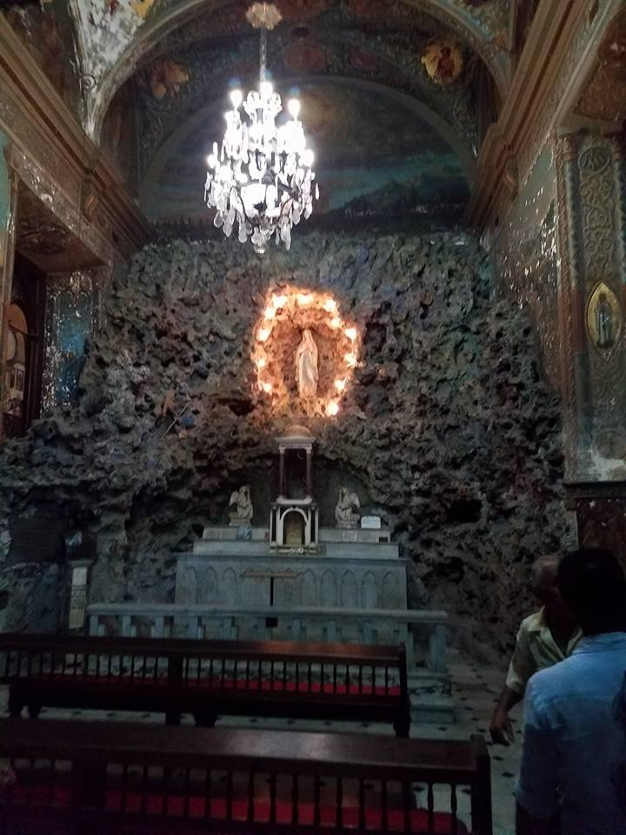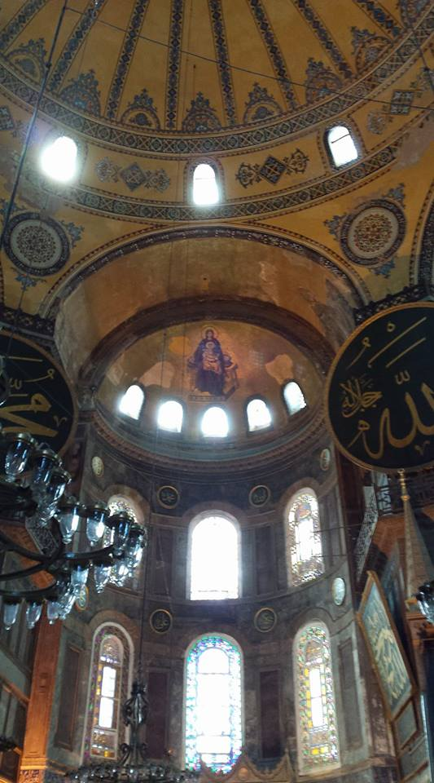[Pick the date]

|  |
| --- |
|  |

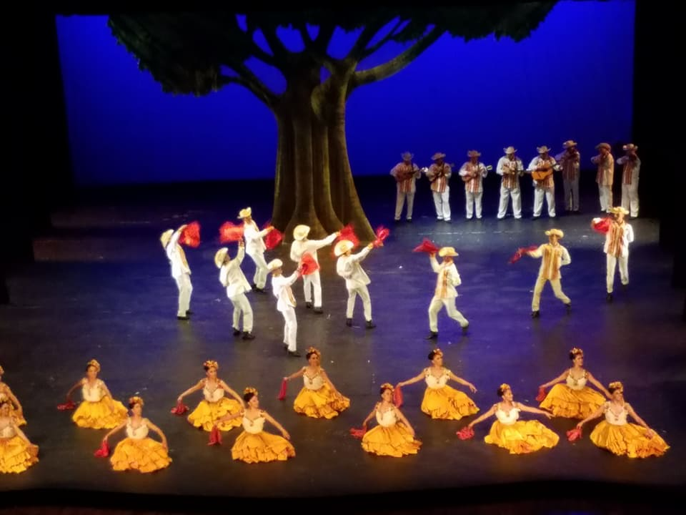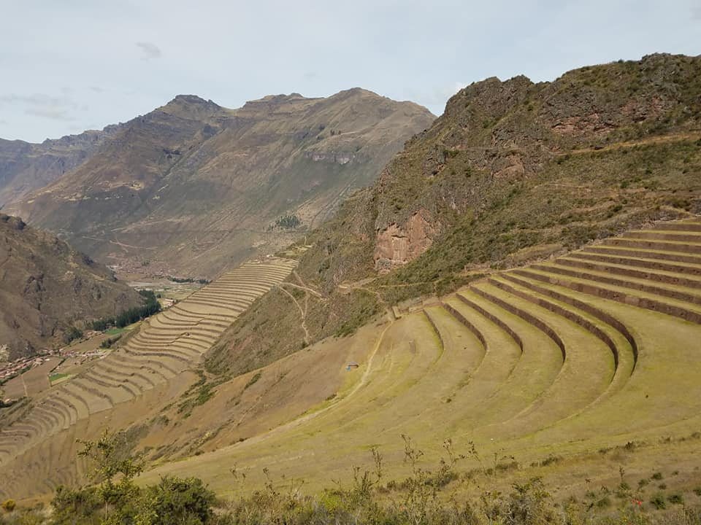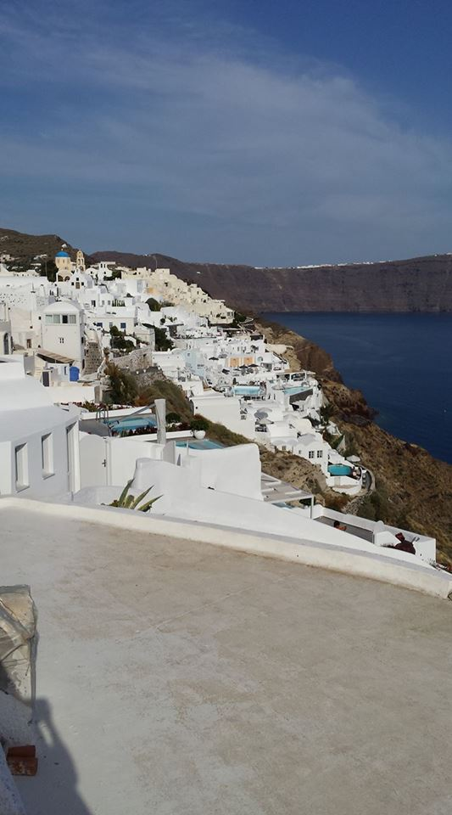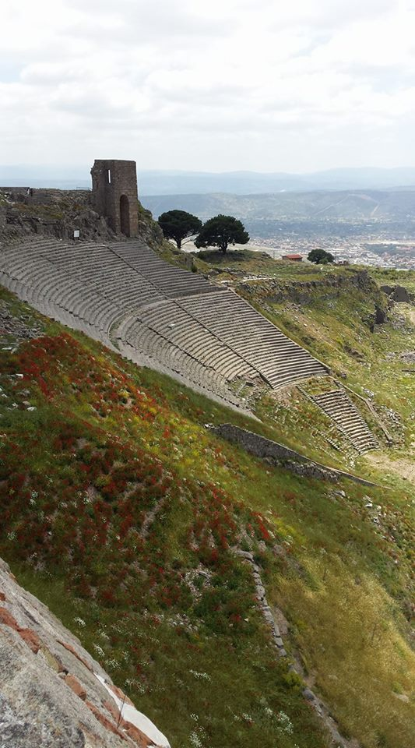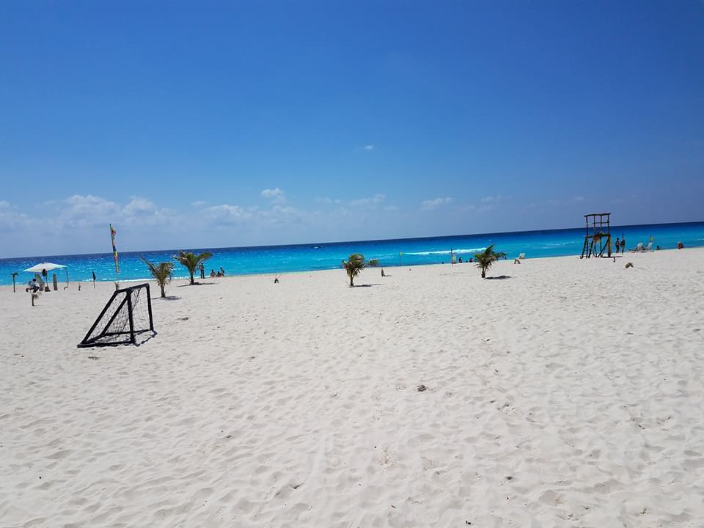

**INTERNATIONAL CULTURAL JOURNEYS**

|  |  |
| --- | --- |
|  | AN INTRODUCTION TO CULTURAL & INTERNATIONAL STUDIES |

**DEDICATION**

This book is dedicated to the spirit of adventure, joy of traveling, love of learning, pursuit of academic freedom, advancing the Cultural/International Studies field, challenging the status quo, classrooms without letter grades/deadlines and all people considering Cultural/International degrees, jobs and or careers.

**PREVIEW NOTICE**

Seeing as how this book hasn’t been officially released yet and is still under a final audit, it possible that a few page numbers might be different from the book when it is officially released and there might potentially be a few variations. In addition the Table of Contents is customized to what is in this specific preview.

**AUHTOR BIAS & DISCLOSURES**

In the book there will be a section on author bias and disclosures about stuff mentioned/used in the book.

**AUTHOR PAST PAPERS**

To see a list of major assignments and papers complete by David Monlux go to the personal website at <https://www.davidmonlux.com/works>

**THANK YOU ACKNOWLDEGEMENT TIMELINE**

In the book there will be a list of over 35 thank you mentions toward the beginning.

**AUTHOR EXPERIENCE**

*Completed & Passed Classes at Time of Publication*

|  |  |  |
| --- | --- | --- |
| Cultural Courses | International &  Area Studies | Political Science |
| HUM 2603: Global Studies in  Humanities: Greece/Turkey: Taken  in Greece/Turkey (Rose: SP 14)  TA 1103: Intro to Theatre  (OCCC: FA 14)  ENGL 2143: Classical Mythology  (Rose: SP 15)  HUM 2413: American Cultural  Experience (Rose: SP 15)  HUM 2423: Global Cultural  Experience (Rose: FA 15)  HUM 2313: American Humanities  (Rose: FA 15)  GEOG 2603: World Regional  Geography (OCCC: SP 16)  HUM 2133: Comparative Religions  (OCCC: SP 16)  ANTH 3253: Anthropology of  Language/Culture  (OSU-OKC: FA 16)  ESP 112: Mexican Culture & Lit:  5 credit hours. (UPAEP[[1]](#footnote-1): SP 17) | IAS 3003: East Euro Politics/Society (OU: SP 16)  IAS 3003: Practice of Diplomacy taught by US State Dept Diplomat in Residence.  (OU: SP 16)  IAS 3013: International Law  (OU: SU 16)  IAS 3083: International  Activism (OU: FA 16)  IAS 3273: The EU:  (OU: FA 16)  IAS 3742: Model UN  (OU: FA 16)  IAS 3000: Cuban Culture/Politics  (Taken in Cuba): 3 credit hrs  (CIEE/OU: SP 17)  ERA 3063: Intro to Terrorism Threats (OSU-OKC: SU 17)  IAS 4970: Diplomacy Lab II  US Embassy Moscow Project  (3 Credit Hours: OU: FA 17)  IAS 3000: BREXIT  (1 credit hour: OU: SP 18)  IAS 3940: Journey to Latin America (Taken in Peru):  6 credit hrs. (OU: SU 18) | POLS 1113: American Fed Govt (Rose: FA 13)  POLS 2203: Intro to Public Policy (Rose: FA 15)  POLS 2503: Intro to International Relations (Rose: FA 15)  P SC 3220: Career Planning in Intl/Nat Security: 1 credit hr (OU: SP 16)  P SC 3550: Politics in International Law: 3 credit hours (OU: SU 16)  P SC 4220: Game Theory:  3 credit hours (OU: FA 16)  P SC 3600: Politics of Mexico:  3 credit hours (Taken in Mexico: SP 17)  P SC 3653: Govts/Politics of  Latin America (Taken in Mexico: SP 17)  P SC 4873: Tools of State Craft (OU: FA 17)  P SC 4283: Civil Rights/Liberties (OU: FA 17)  P SC 3553: International Political  Economy (OU: SP 18)  P SC 4863: Strategic Intelligence (OU: SP 18)  P SC 4093: Polisci Capstone:  Architecture of Democracy (OU: SP 18)  P SC 2223: Making Public Policy (OU: FA 18) |
| Total: 32 | 33 (65) | 40 (105) |

**Study Abroad Countries: Cuba, Greece, Mexico, Peru & Turkey. Major International Club Participation: OU Model Arab League**

**PREVIEW TABLE OF CONTENTS**

0: Cover

1: Blank

2: Dedication

3: Preview Notice, Author Bias/Disclosures, Author Past Papers & Thank You Acknowledgement Time Line

4: Author Experience

5-7: Table of Contents

8: Transition Page from Pre Reqs to Introduction

9-12: Introduction (The Journey Begins)

13: Transition Page from Introduction to Chapters

14-44: Chapter 1: The Basics: *Elementary My Dear Watson*[[2]](#footnote-2)

14: Careers/Jobs Available in the Field

15: 30 Research Beginnings

16-19: 20 Need to Know International Organizations

20-23: 36 *Books of Spirits Past[[3]](#footnote-3)*

24-31: *You Can’t Handle the Jargon[[4]](#footnote-4)*

32-44: Theorist and Their Theories

45-46: Chapter 2: *You are Young, Set Your Discipline on Fire, Make it Burn Brighter[[5]](#footnote-5)to Shine Bright Like a Diamond[[6]](#footnote-6)*

45-46: Discipline Chart

47-54: Chapter 3: *Should I Skip or Should I Go[[7]](#footnote-7)* Cultural/International Studies? Do *Far Far Away[[8]](#footnote-8)*Lands Await You with that *1st Step of 1,000 Miles?[[9]](#footnote-9)*

47-49: 50 Cultural/International Studies Degrees in the US

49-53: Spending Your Entire College Career Abroad (Start Packing)

54: 14 Private Study Abroad Options

55-56: Chapter 4: *To be OR Not to be[[10]](#footnote-10)* in International Studies? *That is the Question[[11]](#footnote-11).*

56: Elemental Table of International Studies

57-58: Chapter 5: Cultural Studies (*We R Who We R[[12]](#footnote-12)*)

57: Cultural Circle & Cultural Table of Elements

58: Explanations and Details of the Cultural Circle and Cultural Table of Elements

59-75: Chapter 6: Terrorism & Human Rights (Fear of *Liberty, Justice and Order for All[[13]](#footnote-13)*)

59-62: *Terrorist Terrorist, Whatcha Gonna Do When the International Task Force Comes for You? Terrorist![[14]](#footnote-14)*

62-68: 8 Atrocities of Past

69-75: 6 Present Day Human Rights Violations (First 2 available. For last 4 buy the book)

75: Major Human Rights Documents, Current Human Rights Advocacy/Watch Dog Groups, Current Human Rights Scoring Systems/Measurements, Monlux View on Human Rights, New Proposed Human Rights Scoring System & FAQ’s

76: Chapter 7: *Loco Motion[[15]](#footnote-15)* & *Cha Cha Slide[[16]](#footnote-16)* of Nations *Meant to Fly[[17]](#footnote-17)*

76: Nation Triangle & Elemental Table of Nationhood

76: Nation Formation & Deformation, Monlux Scoring System to Define Nation Status, Examples, Rankings, Explanations & FAQ’s

77-80: Chapter 8: *Good Riddance Stationary Life! Studying Abroad, It’s Experiences Unpredictable but in the End is Right, You’ll Have the Time of Your Life[[18]](#footnote-18)*

77-78: Destination Selection Process (*Any Way You Want It[[19]](#footnote-19)* To Where?)

79: Cost of Living Considerations (*That’s The Way Uh Huh Uh Huh I Like It[[20]](#footnote-20)*)

80: Health & Safety (Better Safe Than Sorry)

80: Experience of the Author Abroad (*I Went, I Saw, I Transformed[[21]](#footnote-21):* Buy the book to read about the Study Abroad Experiences of Monlux)

81: Conclusion (Greatest Hits & *The Final Count Down[[22]](#footnote-22)* to *Infinity & Beyond[[23]](#footnote-23)*: Buy the Book to read the Conclusion)

81: Works Cited/References & Picture/Chart/Graph References/Credits (Will be included in the final draft)

**TRANSISTION FROM PRE REQS TO INTRODUCTION**

**THE JOURNEY BEGINS**

Like Nelly most people grow up with *Just a Dream[[24]](#footnote-24)* of traveling the World and seeing the sites to only become possession of the grim reaper. For many the reality of *Price is* NOT *Right[[25]](#footnote-25)* , family obligations get in the way and or lacking vacation time interferes with enjoyment of life. Despite flights that jet to Earth’s opposite end within 24 hours, many people remain in one (1) country from birth to death. This doesn’t have to be the case. In the words of Journey **“Don’t Stop Believing”** to be the **“Some will win”** instead of the others losing out on their financial/physical health or lack of time **“to sing the blues”** of regrets not having traveled. One way to ensure international travels and exotic adventures await you is choosing to study Cultural/International Subjects and seeking jobs in the Global Community. This book attempts explanation of the jargon, theorist, disciplines, educational pursuit opportunities, international studies, cultural studies, human rights, nation formation/deformation and travel/studying abroad in hopes that it becomes your reality instead of remaining *Just a Dream* with Nelly before being collected by the Grim Reaper. As follows, here is an overview of what each chapter entails to see if you can make this path *Written in the Stars[[26]](#footnote-26)* for you instead of being a million miles away.

Like most intro books, *We Will We Will Rock You[[27]](#footnote-27)* with the critical/crucial boredom foundational knowledge of the basics in chapter 1. The first section mentions 20 different options of jobs/careers in the field while the 2nd section gives you 30 different places to obtain information via your *Independence Day[[28]](#footnote-28)* for your own research. Depending upon the results of your research you are either the aliens taking over by redefining your field or holding to traditional values of life as you know it being PresidentThomas J. Whitmore giving the final speech from Area 51. Regardless if you are ground breaking or clinging to what you know, you will need research sources and data to back up your claim. Section 3 covers 20 very important and high profile international organizations. Section 4 provides categories of 10 different subjects that will be recurring themes in the field of Cultural and International Studies in total recommending 36 different books. As realities are different for people based off their knowledge, experience and location, the jargon in the fields and disciplines also means that different words have different meanings to different people. An incredible example of different World views is Lt. Kaffee in the Navy Yard as compared to Col Jessup at Guantanamo Bay Cuba who has Cubans wanting to shoot him at breakfast in the movie *A Few Good Men[[29]](#footnote-29)*. In different fields the exact same word can mean different things, thus leading to two completely different truths that the other can’t handle. That is why some terms of the jargon are defined in section 5. Section 6 contains oversimplifying summaries of 22 different major theorist theories with most having pictures and graphs. Chapter 2 then gives a brief overview introduction to the different disciplines of cultural and international studies with the highlights being Trade Agreements/Deals, Stock Markets, a Diplomacy graphic, the Triple Threat Corruption Chart and the Power Puff Girl Chemical X Chart.

Now that the boring basics of chapter 1 have rocked your World and the disciplines are understood, chapter 3 can start with planning your path to travel enlgightment. The first section lists 50 different options for students to obtain degrees in Cultural and or International Studies within the US. Section 2 list universities in 30 different countries where a person can obtain a degree outside the US and have the primary language of all their classes be in English. Section 3 lists 14 different private study abroad companies. Chapter 4 then gives a two (2) page summary on the International Studies field while introducing the International Studies Elemental Table. Chapter 5 goes into tremendous detail on Cultural Studies and explores the factors/products of environment giving truth to Kesha when she sings *We R Who We R* [[30]](#footnote-30) no matter how much of *An Inconvenient Truth[[31]](#footnote-31)* it might be. Included are the Cultural Circle and Cultural Table of Elements created by Monlux before going into detail on the various areas of culture.

Now that the Journey has begun with the basics understood, you’ve determined that you can handle the truth of jargon in these fields/disciplines, know 25 theorist’s theories, have researched your cultural/international educational opportunities, understand International and Cultural Studies, the real fun of blasting off with Buzz Lightyear to Infinity and Beyond begins. To paraphrase *Let’s Get It Started[[32]](#footnote-32)* by the Black Eyed Peas **“Let’s get fun started, in here”** with chapter 6 going by beginning with 6 terrorist organizations before going into human rights which is a serious matter. It will cover blatant atrocities committed in the past that violated human rights in Armenia, Bangladesh, Cambodia, Chile, East Timor (Timor Leste), Middle East, Nazi Germany and Rwanda. It will then shift gears to present day human rights violations in China, Myanmar, North Korea, Saudi Arabia, Turkey and Venezuela. A list will then be provided of major human rights documents and human rights advocacy/watch dog groups and organizations before giving an overview of current major human rights scoring system. The chapter then ends with the Monlux view on Human Rights and his proposed new Human Rights Scoring/Ranking System first proposed in his 2017 paper about Human Rights in Cuba. Chapter 7 then transfer to the *love* of *rock and roll[[33]](#footnote-33)* sexy topic of Nationalism that *soothes the soul*[[34]](#footnote-34) which is a fancy name for Nation formation and deformation. In order to better define and expand on Nation formation and deformation Monlux proposes the Nation Pyramid and Elemental Table of Nationhood combined with a scoring system followed by examples before ending the chapter with FAQ’s on the new proposal. Chapter 8 then ends on a fun note with studying abroad. To paraphrase Star Trek, chapter eight (8) will **“Boldly go where no textbook has gone before”[[35]](#footnote-35)** by being divided into four (4) different sections. It examines the destination selection process, cost of living considerations, health/safety risk and the experience of the author abroad. This book then heads to the finale known as the conclusion to reach the final boarding call at the departure gate with the standard works cited, references, credits and the required/protectionary legality compliance/disclosure about stuff in this book.

Choosing to pursue a Cultural/International education is a life changing experience that should be done with the utmost consideration between the travel, risk and exposure to new ideas/people that is sure to be involved. Many businesses are going global while travel jobs are multiplying. This book is an attempt to explain and help you decide if you wish to be a part of that and study further. As it’s been said many times before **“Only You Can Prevent Wildfires”** and “**Uncle Sam Wants You to Join the US Military”** many companies Want **You to Study Cultural/International Studies** and **Only You Can Choose Your Career Path!** It is the hope of the author that you will find this book beneficial in making both your College Education and Career Path selections. Please choose the path that is best for you while remembering the global increase of the world and rampant exposure to mass cultures. As you embark upon the journey which begins with reading this book, **May the Force be with You[[36]](#footnote-36)** so that you may **Live Long and Prosper[[37]](#footnote-37)** in your future career(s) and endeavors. As Ash left Pallet Town **to be the very best like no one ever was[[38]](#footnote-38),** you will also begin your journey in an attempt to become an Alpha or Beta in this ever changing *Brave New World[[39]](#footnote-39)* of Globalization for your field of specialization and or sub specialization. Rather than hold you up any further with this introduction, its time to get to the basic concepts in the field contained within the actual chapters. In the words of Chris Cuomo on Prime Time **“Let’s get after it.”**

**TRANSISTION FROM INTRODUCTION TO CHAPTERS**

**CHAPTER 1: ELEMENTARY MY DEAR WATSON**

**SECTION 1: POTENTIAL CAREER/JOB OPPORTUNTIES**

|  |  |
| --- | --- |
| 1: CIA | 11: INTERNATIONAL JOURNALIST |
| 2: COMMUNITY ORGANIZER | **12: INTERNATIONAL ORGANIZATIONS** |
| 3: CONGRESSIONAL RESEARCH SERVICE | **13: INTERNATIONAL RELIGIOUS MINISTRIES** |
| 4: COUNTRY/REGION SPECIFIC ANALYSIST | **14: LANGUAGE TRANSLATOR** |
| 5: CULTURAL ADVISOR/CONSULTANT | **15: MILITARY** |
| 6: CULTURAL/INTERNATIONAL STUDIES EDUCATOR | **16: NON GOVERNMENTAL ORGANIZATIONS (NGO’S)** |
| 7: DIVERSITY COMPLIANCE OFFICER | **17: PEACE CORPS** |
| 8: FBI COUNTER INTELLIGENCE | **18: PRIVATE POLITICAL BUSINESS ADVISOR** |
| 9: FLIGHT ATTENDANT | **19: THINK TANKS** |
| 10: FOREIGN SERVICE OFFICER | **20: TOUR GUIDE/TRAVEL AGENT** |

***SECTION 2: 30 RESEARCH POINT BEGINNINGS***

|  |  |
| --- | --- |
| RESEARCH SOURCE (Listed Alphabetically) | WEBSITE OR DESCRITION |
| 1: Asian Infrastructure Bank  2: Brookings Institution  3: CATO Institute  4: Center for Strategic & International Studies  5: CIA World Factbook  6: Clinton Foundation  **7: Constitute Project (Contains copies/translations of most Constitutions of most Countries in most languages)**  8: Council on Foreign Relations  9: CSPAN Archives  10: CSPAN Video Library:  11: European Union (EU) Archives  12: Foreign Government Archives  13: Foreign Policy Research Institute  14: Google Scholar (Need sources fast? Google Scholar)  15: International Criminal Court  16: International Monetary Fund (IMF)  17: International Institute for Strategic Studies  18: Kellogg Institute for International Studies  **19: Library of Congress (Has incredible records of House Foreign Relations/Senate Intelligence Committee Meeting Minutes, reports and expert testimonies/submissions)**  20: News Organizations/Outlets  21: Organization of American States (OAS) Archives (mix of multiple languages)  22: Rand Cooperation  23: Research Gate  24: Sources your professors hint/recommend/tell you  25: Subject Matter Book(s) written by Expert(s)  26: Textbooks  27: United Nations (UN) Archives | <http://www.aiib.org/>  <https://www.brookings.edu/>  <https://www.cato.org/>  <https://www.csis.org/>  <https://www.cia.gov/library/publications/the-world-factbook/>  <https://www.clintonfoundation.org/>  <https://www.constituteproject.org/>  <https://www.cfr.org/>  <https://www.c-span.org/organization/?419/Archives>  <https://www.c-span.org/about/videoLibrary/>  <https://europa.eu/european-union/documents-publications/libraries-archives_en>  *Varies by Government*  <https://www.fpri.org/>  <https://scholar.google.com/>  <https://www.icc-cpi.int/>  <https://www.imf.org>  <https://www.iiss.org/>  <https://kellogg.nd.edu/>  <https://www.loc.gov>  *Highly variable. Check organization bias.*  <http://www.oas.org/en/iachr/decisions/archive.asp>  <https://www.rand.org/>  <https://www.researchgate.net/>  *They hold the key to your grade*  *Very valuable*  *Might impress the prof*  <https://archives.un.org/> |
| 28: University Library Databases  29: US State Department Travel Advisories/Warnings.  **30: World Prison Brief, Institute for Criminal Policy Research Birkbeck, University of London (For Prison research, statistics & conditions this is the go to for data)** | Consult your University Library  <https://travel.state.gov/content/travel/en/traveladvisories/traveladvisories.html/>  <http://www.prisonstudies.org/> |
| RESEARCH SOURCE (Listed Alphabetically) | WEBSITE OR DESCRPTION: |

**SECTION 3: 20 NEED TO KNOW INTERNATIONAL ORGANIZATIONS**

|  |  |  |
| --- | --- | --- |
| GROUP/ORGANIZATION | WEBSITE | DESCRIPTION |
| African Union**1: AFRICAN UNION (AU)** | [**https://au.int/**](https://au.int/) | Has over 50 member countries of Africa with the goal to rid Africa of colonization influence & apartheid; while promoting unity/solidarity among all African Nations; It also tries to unify economic and trade policy while coordinating the majority of the trade deals between/with countries in Africa. |
| **2: ALJAZEERA**  al jazeera  **3: ARAB LEAGUE**  Flag of the Arab League  **4: ASIAN INFASTRUCTURE BANK**  AIIB logo.png  Flag of Brazil.svg**5: BRAZIL, RUSSIA, INDIA, CHINA & SOUTH AFRICA (BRICS)**  Image result for bbc logo**6: BRITISH BROADCASTING CORPORATION (BBC)**  Image result for bbc  **7: DOCTORS WITHOUT BORDERS** | [***https://www.aljazeera.com***](https://www.aljazeera.com)  [***http://www.lasportal.org/ar/Pages/default.aspx***](http://www.lasportal.org/ar/Pages/default.aspx)  https://upload.wikimedia.org/wikipedia/commons/e/e7/Arab_League_Summit_Logo.png  [***http://www.aiib.org/***](http://www.aiib.org/)  Flag of the People's Republic of China.svg  ***NA***  Flag of South AfricaFlag of India.svgFlag of Russia.svg  [***http://www.bbc.com/***](http://www.bbc.com/)  [***https://www.doctorswithoutborders.org/***](https://www.doctorswithoutborders.org/)  https://branding-guidelines.msf.es/eng/imgs/logomsf-int.png | Based out of Qatar, Aljazeera is the leading news organization in the Middle East. They have highly accurate reporting. For Middle Eastern news, viewpoints & perspectives they are a great place to start.  The Arab League is an organization comprised of 22 Arab Countries and has 5 observer seats. It is a major player in Middle Eastern Politics and an important organization to learn about.  Is a 52 member organization based in China giving out loans, development projects and investments. Despite its name, it has made a number of investments in both Latin America & Africa. Its rumored that China is using it as leverage tool in foreign policy.  Economic trading block of five big countries around the World.  A major news network based in the UK with reporters in all countries with high degrees of accuracy/fairness in reporting.  An organization dedicated to providing medical care for all at greatly reduced cost or free. It was originally French. While in the US/English speaking world it is known as Doctors Without Borders, to most of the rest of the World it is Medecins Sans Frontiers. |
| **8: EUROPEAN UNION (EU)**  70 years of lasting peace  **9: G20**  https://www.g20.org/sites/default/files/files/1_genericas/G20%20importance.jpeg  **10: INTERNATIONAL CRIMINAL COURT** | [***http://europa.eu/***](http://europa.eu/)  [***https://www.g20.org/en***](https://www.g20.org/en)  [***https://www.icc-cpi.int/***](https://www.icc-cpi.int/) | At the time of publication the EU is presently a 28 member organizations of independent countries in Europe. The UK in the BREXIT referendum voted to leave and is in the process of withdraw which will leave the EU down to 27 member states. The core of the EU is Human Dignity, Freedom, Democracy, Equality, Rule of Law and Human Rights for all. It has its own parliament, court of justices, currency and many other functions/spheres of influence in the World. The peace in the graph refers to Europe.  An organization devoted to economic policy development made up the World’s 19 leading economies plus the European Union with guest input from other countries.  Was created by the Rome Statute. When states are unwilling or unable to prosecute crimes, the International Criminal Court can come in and bring charges on these 4 areas. 1: Genocide. 2: Crimes Against Humanity. 3: War Crimes in violation of the Geneva Convention OR excessive attacks on civilian populations. 4: Crime of Aggression (no one has ever been prosecuted for Crime of Aggression.) In addition the International Criminal Court only applies to countries under its jurisdiction and all prisons are hosted in member countries. The International Criminal Court itself doesn’t have its own prison system for sentencing, however does hold a pretrial detention center. |
| **11: INTERNATIONAL MONETARY FUND (IMF)**  Image result for international monetary fund  **12: INTERPOL**  Image result for interpol | [***https://www.imf.org/external/index.htm***](https://www.imf.org/external/index.htm)  [***https://www.interpol.int/***](https://www.interpol.int/) | A 189 member organization based out of Washington DC. It provides capital for infrastructure investment projects and loans to struggling countries. It is usually viewed as a lending institution of last resort.  Has 194 member countries. Its political headquarters in Lyon France while its technical operations are located at the Global Complex for innovation in Singapore. It has 7 regional headquarters, representatives at the AU, EU & UN. Each member country has its own National Center Bureau along with offices in major international airports. It has a large database of information and works on police cooperation/training initiatives. |
| **13: NORTH ATLANTIC TREATY ORGANIZATION (NATO)**  The NATO logo | [***https://www.nato.int/***](https://www.nato.int/) | NATO is a 29 member organization committed to the defense of the northern hemisphere and countries that are in or border the Atlantic. It also promotes Democratic ideals and freedoms around the World. It also works to combat Russian aggression and serves as a defense mechanism with Article 5. |
| Flag of the People's Republic of China.svgFlag of Belgium.svgFlag of Belarus.svgFlag of India.svgFlag of Iran.svgFlag of Italy.svg**14: NUCLEAR WEAPON COUNTRIES** | Flag of Germany.svgFlag of France.svgFlag of Israel.svgFlag of the Netherlands.svgFlag of North Korea.svg***NA*** | Belarus, Belgium, China, France, Germany, India, Iran, Italy, Israel, Netherlands, North Korea, Pakistan, Russia, South Africa, Turkey, UK, Ukraine & USA. (There are unconfirmed rumors or circumstantial evidence of other potential countries.) |
| Flag of Turkey.svgFlag of South AfricaFlag of Russia.svgFlag of Pakistan.svg  OAS Logo**15: ORGANIZATION OF AMERICAN STATES (OAS)** | Flag of the United States of AmericaFlag of Ukraine.svgThe Union Flag: a red cross over combined red and white saltires, all with white borders, over a dark blue background.  [***http://www.oas.org/en/***](http://www.oas.org/en/) | Includes membership of 35 countries while working to implement and promote democratic ideals across the America’s while granting observer status to 69 different countries |
| **16: UNITED NATIONS (UN)**  http://www.un.org/sites/www.un.org/files/styles/large/public/2014/11/19/wide-view-un-general-assembly-hall.jpgHome  **17: US STATE DEPARTMENT**  Flag of the United States Department of State.svgU.S. Department of State official seal.svg  **18: WORLD BANK**  The World Bank logo.svg  Flag of WHO.svg**19: WORLD HEALTH ORGANIZATION (WHO)** | [**http://www.un.org/en/index.html**](http://www.un.org/en/index.html)  [**https://www.state.gov/**](https://www.state.gov/)  [**https://www.worldbank.org/**](https://www.worldbank.org/)  [**https://www.who.int/**](https://www.who.int/) | The United Nations stands as the World’s largest organization and most countries (excluding Taiwan. #Let them join) are allowed to join. Its mission promotes the furthering of peace and understanding among nations while funding many valuable programs and its famous Security Council.  The US State Department (particularly the Foreign Service) handles most of the Diplomatic and negotiation aspects of US Foreign Policy. It also provides citizen and emergency services for Americans overseas. If traveling register in the Smart Traveler Enrollment Program (STEP).  The World Bank works to combat poverty and increase the income level of the bottom 40% of income earners.  On April 7th (World Health Day) 1948 the World Health Organization (WHO) came into existence. It is currently headquartered in Geneva. It has operations in 150 different countries and works to promote awareness campaigns, basic vaccinations, infrastructure projects in regards to sanitation and health clinics while promoting and funding research for advancement into both cures and preventive measures for diseases. |
| **20: WORLD PRISON BRIEF,**  Image result for birkbeck university of london**INSTITUTE FOR POLICY RESEARCH**  Related image | [**http://www.prisonstudies.org/**](http://www.prisonstudies.org/) | The World Prison Brief Institute for Policy Research looks at prison populations in overall numbers while devolving into sub categories of incarceration rates of women, juveniles and foreign nationals. When available it also documents pre-trial detainees without bail or a hearing, prison overcrowding, assess accuracy of other prison reports, works closely with local organizations, highlights the conditions in most countries and releases in depth reports. |
| **GROUP/ORGANIZATION** | **WEBSITE** | **DESCRIPTION** |

**SECTION 4: BOOKS OF SPIRIT PAST:CATEGORY 1: COMPARATIVE POLITICS**

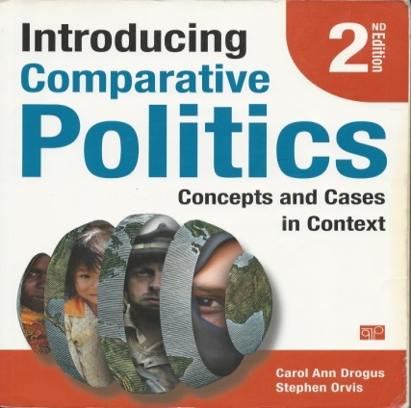[[40]](#footnote-40) 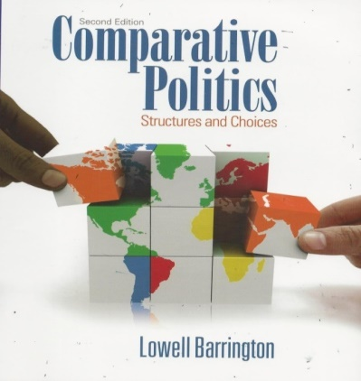[[41]](#footnote-41) 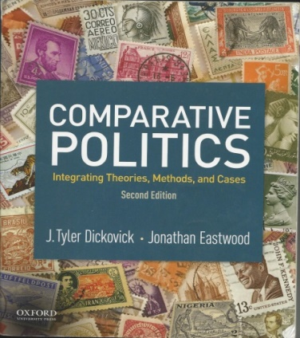[[42]](#footnote-42)

**CATEGORY 2: CURRENCY**

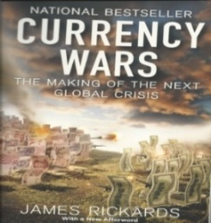[[43]](#footnote-43)

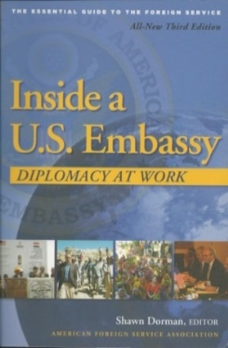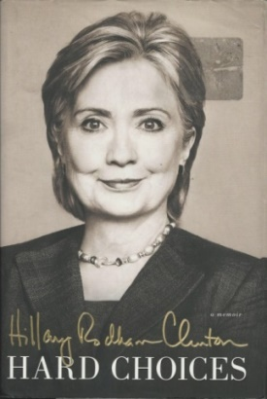 **CATEGORY 3: DIPLOMACY**

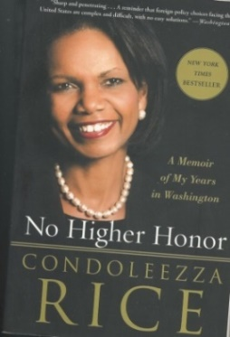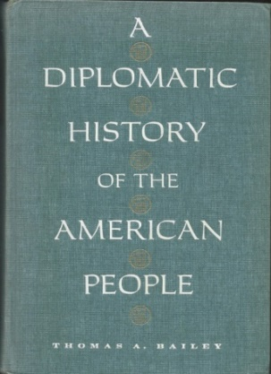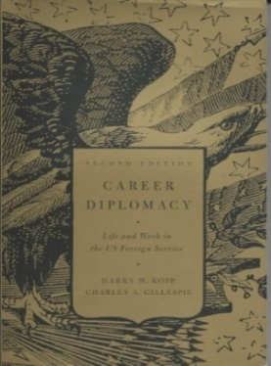

[[44]](#footnote-44) [[45]](#footnote-45) [[46]](#footnote-46) [[47]](#footnote-47) [[48]](#footnote-48)

**CATEGORY 4: GLOBALIZATION**

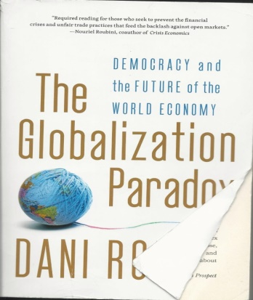[[49]](#footnote-49) 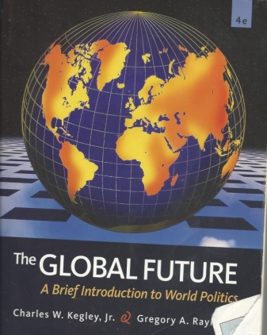[[50]](#footnote-50) 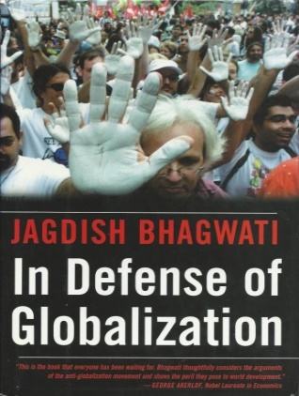[[51]](#footnote-51) 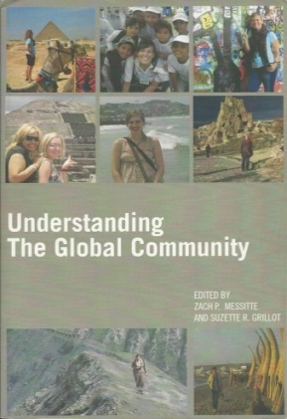[[52]](#footnote-52)

**CATEGORY 5: LATIN AMERICA**

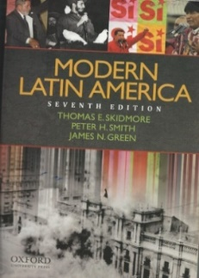 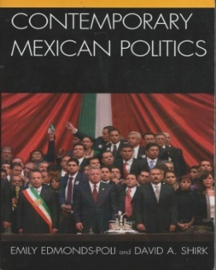[[53]](#footnote-53)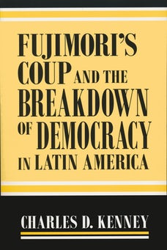[[54]](#footnote-54) [[55]](#footnote-55) 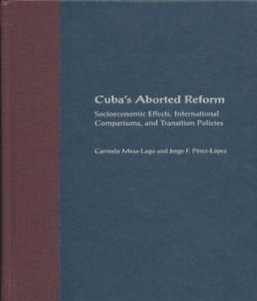 [[56]](#footnote-56) [[57]](#footnote-57)

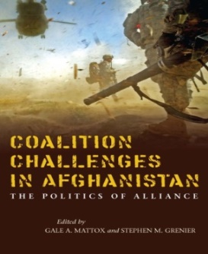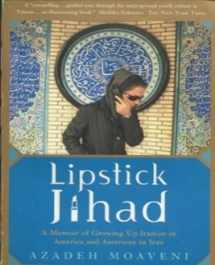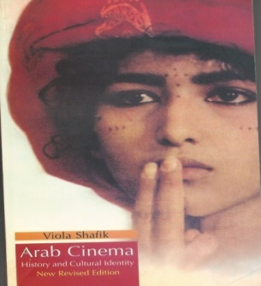 **CATEGORY 6: MIDDLE EAST**

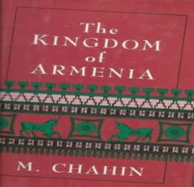

[[58]](#footnote-58) [[59]](#footnote-59) [[60]](#footnote-60) [[61]](#footnote-61)

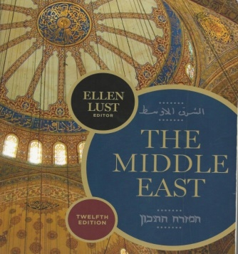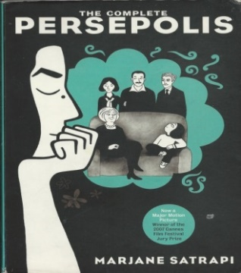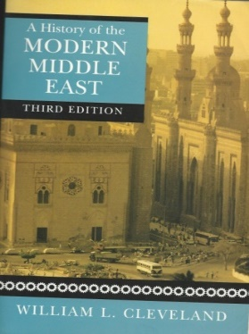

[[62]](#footnote-62) [[63]](#footnote-63) [[64]](#footnote-64)

**CATEGORY 7: NATIONS & NATIONALISM**

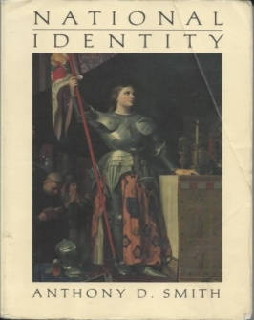[[65]](#footnote-65) 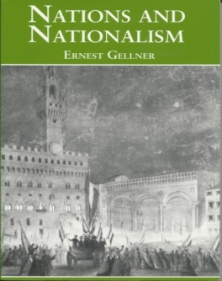[[66]](#footnote-66) 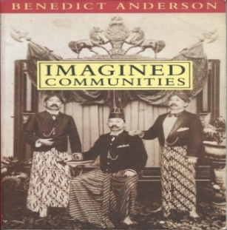[[67]](#footnote-67)

**CATEGORY 8: ORDER & WEAPONS**

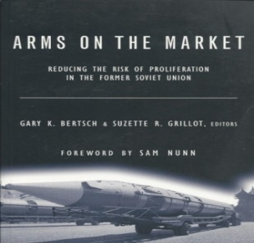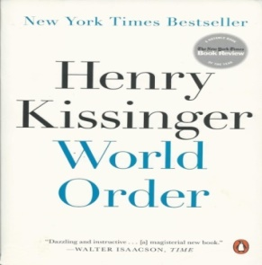

[[68]](#footnote-68) [[69]](#footnote-69)

**CATEGORY 9: RELIGION**

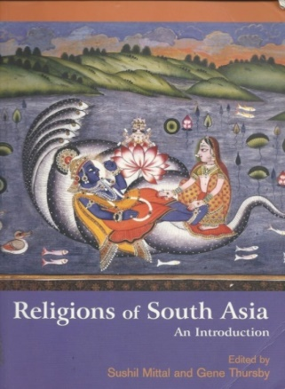[[70]](#footnote-70) 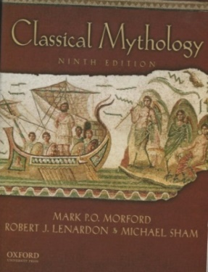[[71]](#footnote-71) 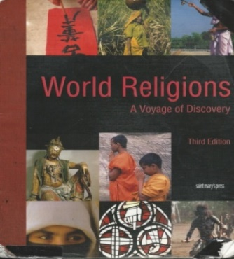[[72]](#footnote-72) 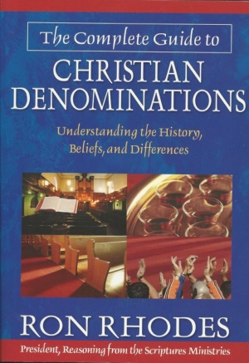[[73]](#footnote-73)

**CATEGORY 10: RUSSIA**

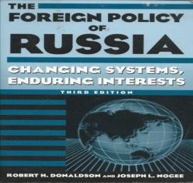[[74]](#footnote-74)

**SECTION 5: YOU CAN’T HANDLE THE JARGON**

|  |  |
| --- | --- |
| TERM: | DEFINTION: |
| 1: Access | The ability to talk to, meet with and or use someone/something when needed. |
| 2: Adviser | Someone in a position of trust or importance for a business or government giving advice and information to a group before decisions are made. |
| 3: Advisory: | A general waring about an area, person, group of people and or weather. Usually issued by the government, weather channel/station and or a business. |
| 4: Afghanistan | A middle eastern country bordered by Pakistan, Iran and Turkmenistan. Lots of poppy seed growing and many countries have had foreign interventions. |
| 5: Africa | A Continent South of Europe, West of Asia and East of Latin/South America. Contains over 50 countries, has a large amount of natural resources and conflict. |
| 6: African Union (AU): | An organization comprised of 55 countries representing the interest of Africa and its nations. |
| 7: Aggression: | Excessive pursuit and or use of force. |
| 8: Aid: | A form or type of help to a group of people or country usually administered by a government. |
| 9: Air: | What people breathe out of and into. |
| 10: Air Force: | The air capability, flights and weapons of a military. |
| 11: Air Space: | The Soveginity of the air in/around a controlled territory/country. |
| 12: Air Quality: | The cleanness and breathability of the air around you. |
| 13: Airplane: | A vehicle craft that flies long distances in the air between destinations/locations. |
| 14: Airport: | A hub, storage place and destination/takeoff point for aircrafts usually in the capacity of commercial and personal flights. |
| 15: Albania: | A country in Europe between Greece, Macedonia and Montenegro. |
| 16: Alert: | Advisory or warning about ongoing/incoming activity. |
| 17: Algeria: | A Country in Northern Africa between Morocco, Tunisia, Lybia, Niger, Mali and Mauritania with Medetreian Sea coastline. |
| 18: Alibaba: | A large Chinese multinational company that is to Asia as Amazon is to the US. |
| 19: Alibi: | A cover story, excuse or truth for where someone was during an event. |
| 20: Alliance: | A group of 3 or more countries/organizations with a common goal and or interest on a particular issue moving in unified action. |
| 21: Alter: | To change a story, a fact, history, what happened and or tampering with the record. |
| 22: Amazon: | A major US online retailer that ships products almost anywhere in the World. |
| 23: Amazon Rainforest: | A major forest nicknamed Lung of the Planet that provides most of the World’s Oxygen supply while cleaning up a large percentage of C02. |
| 24: Ambassador | The highest ranking official of the embassy and consulate network of Country A in Country B that is the official representative of country A either as the personal representative of Congress and or the President/Prime Minister/Royal Family. |
| 25: Antarctica: | An extremely cold continent with concerns about polar caps melting. |
| 26: Arab League | The organization of Arab States made up of 22 countries. |
| 27: Argentina: | A large country in Latin/South America. |
| 28: Armenia: | A Middle Eastern Country that is Christian and is bordered by Azerbaijan, Georgia, Iran and Turkey. Manages to have good relationships with both Russia and the US along with an impressive literacy rate and high percentage of adults with a college degree. |
| 29: Army: | The main military of most countries who are authorized to use force. |
| 30: Artificial Intelligence (AI): | A type of technology used for collecting data and information along with drone strikes. |
| 31: Asia: | A very large continent. |
| 32: Asian Infrastructure Bank: | A rival to the World Bank and IM F providing grants and development projects. While primarily focused on Asia and the Pacific it does give aid/grants in other areas of the World. It currently has 70 members and more Countries are looking to join. |
| 33: Assessment: | A way to measure and report how something is doing and or progressing overtime. |
| 34: Atlantic Ocean: | One of the World’s 4 major oceans. |
| 35: Arctic Ocean: | One of the World’s 4 major oceans. |
| 36: Australia: | A large Continent and its own Country. |
| 37: Bail | Payment to get out of jail while on trial. |
| 38: Baltic Region | Countries that have shoreline along the Baltic Sea: Denmark, Estonia, Finland, Germany, Latvia, Lithuania, Poland, Russia and Sweden. |
| 39: Baltic Sea: | Baltic Sea map.png |
| 40: Baltic States: | Estonia, Latvia and Lithuania. |
| 41: Bangladesh: | A Country in Southeastern Asia. |
| 42: Base | Usually a military installation. |
| 43: Barrier | A block, restriction, hurdle or denial of access to a program or area by an authority or group. |
| 44: Belarus | An “independent” nation state in Eastern Europe widely believed to be a client/puppet state of Russia. |
| 45: Belgium | A Country in Europe. |
| 46: Bhutan: | A land locked country that is hard to access and is the self-proclaimed country of happiness. |
| 47: Blackmail | The illegal exploitation of another person or group. |
| 48: Blockade: | A deliberate and coordinated attempt to prevent the import and export of goods to a country and or area. |
| 49: Boat: | A vessel for navigating bodies of water. |
| 50: Bolivia: | A country in Latin/South America. |
| 51: Bomb: | An explosive device that usually causes damage and can result in loss of life. |
| 52: Bond: | A: Another word for Bail.  B: Government investment return for investors. |
| 53: Bosnia: | A Country/Region (depending upon who you ask) in Europe. |
| 54: Border: | Where one jurisdiction ends and another begins. |
| 55: Border Town: | A town/city close at the outer edge of one jurisdiction and close to another. |
| 56: Brail: | A Written Language for the blind. |
| 57: Bribe: | Illegal exchange of money in exchange for services, contracts and or looking the other way. |
| 58: BRICS: | An economic trading block between Brazil, Russia, India, China and South Africa. |
| 59: Brussels: | The city that is home to the headquarters of NATO and the main headquarters of the European Union. |
| 60: Budapest | The capital of Hungary |
| 61: Buenos Aires: | The Capital of Argentina. |
| 62: Bulgaria: | A country in Eastern Europe. |
| 63: Burma (Myanmar): | A Southeastern Asian Country bordered by Bangladesh, China, India, Laos and Thailand. It is the source of much dispute and controversy. |
| 64: Burn Notice: | A fun and entertaining TV Show about a fictional ex spy. |
| 65: Cambodia: | A Country in Asia. |
| 66: Canada | A Country in North America that has a southern border with the US. |
| 67: Caribbean Countries: | Antiqua & Barbuda, Bahamas, Barbados, Belize, British Virgin Islands, Cayman Islands, Colombia, Costa Rica, Cuba, Dominica, Dominican Republic (DR), Grenada, Guyana, Haiti, Honduras, Jamaica, Mexico, Nicaragua, Panama, Saint Kiss & Nevis, Saint Lucia, Saint Vincent & the Grenadines, Trinidad & Tobago, Turks and Caicos Island, US Virgin Islands and Venezuela. |
| 68: Caribbean Sea: | Caribbean general map.png |
| 69: Cartel: | A Criminal organization usually invovled in drugs, prostitution rings and illegal trafficking of people and or goods. |
| 70: Cell: | A: Jail Cell  B: Sleeper Cell.  C: Terrorist group. |
| 71: Censorship: | The deliberate blocking and or cover up of communication, ideas, ideals and or academic work/research. |
| 72: China: | A large country in Asia, member of the permant 5 on the UN Security Council, primary backer of the Asian Infastructure Bank and a top 2 World Economy. |
| 73: Clinton Foundation: | A large international organization. |
| 74: Colombia: | A large Country in Latin/South America. |
| 75: Commercial Flight: | A flight for civilians to facilate business and tourist travel. |
| 76: Constitution: | The legal governing document of a country, region, territory and or organization. |
| 77: Constitutional Monarchy: | A governing set of rules that puts restraints on the power of a monarch. |
| 78: Consul: | A person appointed by the government of country A to live in a city of country B and promote the interest/concerns of the citizens of Country A in Country B. |
| 79: Consul General: | The high consul of a region and supervising/in charge of other consuls for her/his country. |
| 80: Consulate: | The official building of Country A in Country B where official business of government A takes place in that country. |
| 81: Cover Up: | The act of changing the official record, lying, making people forget, bribing people, changing the narrative and or going to great links to make something never sees the light of day or people forget. |
| 82: Covert Affairs: | An entertaining series about a fictional character who is a spy for the CIA. |
| 83: Crude: | A valuable commodity on the market. |
| 84: Cuba: | A Communist Country in the Carribean Sea 90 miles away from the US. |
| 85: Cultural Studies | See Chapter 5: Cultural Studies: We R Who We R |
| 86: Currency | The official money or method of payment in a country and traded on the market with other countries. |
| 87: Customs: | A: Traditions and standards within society.  B: A legal port of entry where you get your passport stamped and or visa issued. |
| 88: Dangerous: | Full of risk and liabilty that could potentially backfire on your career, repuation and or life. |
| 89: Digging: | Research of looking for dirt and or past discretions on people. |
| 90: Dinosaur: | An old person not with the time no longer useful in their posistion . |
| 91: Diplomacy: | The practice of working on relationships. |
| 92: Diplomat: | An official representative of a government in a foreign coutry with diplomatic immunity. |
| 93: Diplomatic Immunity: | Unabled to be prosecuted or charged with a crime. |
| 94: Disappear: | To vanish and not be found. |
| 95: Dominican Republic (DR): | A country in the Caribbean Sea that shares an island with and borders Haiti. |
| 96: Due Diligence: | Going to extreme links of research to verify while dotting all the I’s and crossing all the t’s. |
| 97: Duty: | A commitment/requirement to a job, ideology, religion and or country. |
| 98: Ecuador: | A country in Latin/South America. |
| 99: Education Access: | The ability of a people to be able to both attend and afford a quality school with the lower levels being compulary and free. |
| 100: Embassy | Official residence/offices of an ambassador or diplomatic envoy mission of Country A in Country B sent by the highest authority of diplomatic issues from country A. |
| 101: Emigration: | People leaving their country of citizenship and or primary residence. |
| 102: Ethiopia: | A Country in Africa. |
| 103: Europe: | A Continent. |
| 104: European Union (EU): | A large organization of European States with its own parliament, court of justice, currency and monetary policy. |
| 105: Evade: | To bend/get around rules and or avoid being caught. Usually used to refer to a contry sneaking around sanctions or a criminal evades the police and isn’t caught. |
| 106: Extortion: | The use of threats or forces to obtain something. |
| 107: Favor: | Helping someone out of a jam/tight spot and or difficult situation. |
| 108: Fidel Castro: | A Powerful Leader of Cuba for over 50 years. |
| 109: Forces: | Group(s) of armed militaries/militias. |
| 110: Foreign Aid: | Assistance in the form of money, goods and or services delvered by a government and or NGO to another country. |
| 111: France: | A Country in Europe and part of the permant 5 on the UN Security Council. |
| 112: Fujimori: | A former Peuvian President with Japanese ancestory with a controversial history. |
| 113: Funnel: | To discretely on the down low move funds from one group to another organization despite opposistion, protest and or alleged illegal activity for the purpose of questionable and or illegal activity/projects. |
| 114: Gabon: | A Country in Africa. |
| 115: Game Theory: | A: How to naviagate the buearcratic instituion to get the desired outcome or best potential benefit given the situation.  B: An academic discpline.  C: Sub speciliazation in politics, diplomacy, high stakes negoations and or economics. |
| 116: Games: | Explotation of rules and or procedures to pass something through, burry/destory something and or delay the effects of an outcome out of political, ideological, patriotic, religious and or monetary motiviation. |
| 117: Gaza Strip | A disputed territory in chaos and disary.  Location of the Gaza Strip |
| 118: Georgia: | A: Country in Eastern Europe.  B: One of the 50 US States in the US. |
| 119: Gold: | A precious and valuable natural resource. |
| 120: Gone: | No longer in the place or vicinity. |
| 121: Grounded: | A: Officially off an investigation or project.  B: Flight delayed and not allowed to take off.  C: Forced landing against will. |
| 122: Gülen: | A Turkish statesman living in the US based off self imposed exile. |
| 123: Hamas | A Terrorist organization. |
| 124: Hierarchy: | The structure of an organization, group or royal family that goes from the top down. |
| 125: Hezbollah: | A Terrorist organization. |
| 126: Honduras: | A Country in Latin America. |
| 127: Human Rights: | Basic rights, conditions and puruits that all human beings should be entitled to. |
| 128: Human Trafficking: | The illegal abduction and or movement of people against their will. |
| 129: Hungary: | A country in Europe. |
| 130: Immigration: | The influx of people into a territory/nation both legally and illegally. |
| 131: Indian Ocean: | 1 of the 4 major Oceans. |
| 132: International Studies | See chapter 4: To be OR NOT to be in International Studies? That is the Question. |
| 133: Invasion: | The influx of a large number of people to sway the population demographics/ethnic groups and or a group of people coming into a territory that isn’t theirs by force. |
| 134: Iran: | An Islamic Democratic Republic. |
| 135: Irrigation: | The system to provide water and moisture for crops, plants and livestock. |
| 136: Israel: | A Jewish Nation State with the right to exist and defend itself. Jerusalem is its true capital. |
| 137: Italy: | A country in Europe that includes the famous collsusm, leaning tower of pissa and the Amanda Knox inccident. |
| 138: Jamaica: | An island resort paradise country in the Carribean Sea. |
| 139: James Bond: | An incredible fictional series of a spy for entertainment purposes only and innacurate to the job of 99% spies while the other 1% aren’t as high profile. |
| 140: Jordan: | A Contry in the Middle East. |
| 141: Jurisdiction: | The legal and legimate authority of rule within a given territory. |
| 142: Kangaroo Court: | The outcome is already decided in advance regardless of evidence, one side is blantly favored by the court over the other to receive insider information while the other is denied basic rights of due process, prep time and human dignity in addition to the assumption of innocence/guilt being predetermined. |
| 143: Kazakhstan | A country in central Asia with coast line along the Caspian Sea. |
| 144: Kilimanjaro: | The highest mountian in Africa and located within Tanzania. |
| 145: Latin American Countries: | Argentina, Belize, Bolivia, Brazil, Chile, Colombia, Costa Rica, Cuba, Domincan Republic (DR), Ecuador, El Salvador, French Guiana, Guatemala, Guadeloupe, Guyana, Haiti, Honuras, Mortinique, Mexico, Nicaragua, Panama, Paraguay, Peru, Puerto Rico, Saint-Barthelemy, Saint Martin, Suriname, Uruguay and Venezuela. |
| 146: Lebanon: | A Country in the Middle East. |
| 147: Leverage: | To have an advantage or control on someone or a government. |
| 148: Locked Up Abroad | A show that tells the story of people from one country that get locked up in another country. They share their stories about life behind bars and what the prison conditions of that country are like. |
| 149: Lure: | To trick someone into coming into a location. |
| 150: Mafia (Mob): | An organized international group of criminals using extortion and force to personally enrich themselves and fulfill their power ego. |
| 151: Maneuver: | To skillfully and masterfully doge all obstacles in ones way. |
| 152: Mexico: | A Country that has a northern border with the US. |
| 153: Medetreian Sea: | https://upload.wikimedia.org/wikipedia/commons/thumb/4/49/Mediterranean_Relief%2C_1028_x_1024.jpg/1024px-Mediterranean_Relief%2C_1028_x_1024.jpg |
| 154: Micro Loan: | Short-term loans with a low-interest rate for self-employed individuals, new startups with very low capital requirements or small businesses with only a few employees. They are usually disburesed in developing countries. There is also a trend for 1 time educational expenses in the US. |
| 155: Military: | All branches of the armed forces sanctioned by a government. |
| 156: Moldova: | A country in Eastern Europe. |
| 157: Monitor: | To observe, access, watch and follow a situation closely from a distance over time. |
| 158: Morocco: | A Middle Eastern and North African Country. |
| 159: Mosuo People of China | A female run and dominated society. |
| 160: MS 13 (Mara Salvatrucha): | An organized crime and terrorist group invovled in criminal/illegal activity and causing terrible chaos and loss of life on American Citizens within America. |
| 161: Native: | Orginal to or first to reach/settle an area. (In an ancestoral sense.) |
| 162: Nigeria: | A country in Africa. |
| 163: North Korea: | A Communist Dictatorship with Nuclear Weapons that oppresses its people and is bordered by China, Russia and South Korea. |
| 164: Null & Void: | No longer valid, operational, functional and or honored/enforced. |
| 165: Nullification: | To cancel, rescend and or withdraw from an agreement. |
| 166: Obama: | A former President of the United States who epxanded health care coverage to age 26 for people to remain on their parents health insurance plan, made it illegal to deny coverage based off pre existing conditions and attemtped to make community college free for Americans. |
| 167: Oil: | An extremely valuable commidity, used in fuel and a major cause of many disputes. |
| 168: Oman | A Middle Eastern Country in the Arabian Penisula. |
| 169: Organization of American States (OAS) Countries: | Antigua & Barbuda, Argentina, Bahamas, Barbados, Belize, Bolivia, Brazil, Canada, Chile, Colombia, Costa Rica, Cuba, Dominica, Dominican Republic, Ecuador, El Salvador, Grenada, Guatemala, Guyana, Haiti, Honduras, Jamacia, Mexico, Nicaragua, Panama, Paraguay, Peru, Saint Kitts & Nevis, Saint Lucia, Saint Vincent & the Grenadines, Suriname, Trinidad & Tobago, Uruguay, USA and Venezuela. |
| 170: Organization of the Petroleum Exporting Countries (OPEC): | An intergovernmental organization that controls the majority of the oil market and fixes prices. |
| 171: Osama Bin Laden: | A Terrorist. |
| 172: Pacific Ocean: | 1 of the 4 major Oceans. |
| 173: Palestine: | An independent and soverign nation in the Middle East with its own territory. However it has no rightful claim to Jerusuelam. |
| 174: Patriotism: | Love of country and loyality to it. |
| 175: Patriarchy: | A male dominated political/social structure that favors men over women while creating unecessary obstacles and or discrimination. |
| 176: Peru: | A Country in Latin/South America with 3 distinct regions of Coastal, Mountainous and Forrest. It includes Machu Picchu. |
| 177: Qatar: | A country in the Middle East. |
| 178: Republic: | A state in which power is held by the people via appointed/chosen/voted representatives. |
| 179: Romania: | A Country in Eastern Europe. |
| 180: Rubber: | A valuable natural resource. |
| 181: Russia: | A big and powerful country that has agression and respect problems with other soverign territories. (Ask Georgia and Ukraine) |
| 182: Saudi Arabia | A Kingdom Country in the Middle East surrounded by desert that denies womens rights, murders journalist abroad[[75]](#footnote-75) and is propped up by US Funding and backing. |
| 183: Siberia: | A very cold place in Russia and home to some notorious prison camps and torture sites. |
| 184: Smuggling: | The illegal movement of goods and people, usually done willingly/voluntarily for purposes of money and or attempted fleeing from justice. |
| 185: South Africa: | The Southern most country on the African Continent. |
| 186: South Korea: | An ally of the US. |
| 187: Spin: | Portraying the issues/truth in the most postive light possible for your side |
| 188: Taiwan | An indepednet soverign country that China must give up its One China Policy and stop pursueing attempts to reunite. |
| 189: Treaty: | A formal written, signed and ratified agreement between 2 or more countries. |
| 190: TSA | The people who search your bags, person and make you go though medical detectors in US airports. |
| 191: Tunisia: | A Country in the Middle East. |
| 192: Turkey: | A Country with a rich history in the Mediterrian/Middle Eastern Region that is the gatekeeper between East and West. |
| 193: Tyrant: | A cruel and illigtmate dictator. |
| 194: Uber: | An app in most countries that helps you obtain and get rides inside major cities. |
| 195: United Arab Emirates (UAE): | A very rich Middle Eastern Country with its capital in Dubai. |
| 196: Vatican | A: An indepednet Country.  B: Headquarters and seat of power for the Catholic Chruch.  C: Official residence of the Pope. |
| 197: Venezuela: | A failed Nation State on the verge of clapse with a civil war show down about to take place between Nicolas Maduro (Current Socialist Dictator) and self proclaimed President opposistion leader Juan Guaidó. (2/13/2019) |
| 198: Visa | A: A card that posistions electronic payment.  B: Brand name of a major credit card.  C: A formal document or stamp by the host government granting legal permission of a foreign national to be in the country of the host governmnet legally. |
| 199: Yemen: | A struggling/failed Nation State of a Country with self proclaimed competing governments that many foreign nations are using for proxy wars. |
| 200: Youth Unemployment: | The percentage of youth unable to get jobs and or make a living wage which leads to long term economic problems. |

**SECTION 6: THEORIST & THEIR THEORIES**

|  |
| --- |
| 1: Alexander Wendt: Social Theory of International Politics[[76]](#footnote-76):  The Social Theory of International Politics written by Alexander Wendt takes the Constructionist approach to International Relations. He expresses the role of shared ideas/norms in the shaping, development and motivation of state behavior. It raises questions about the liberal and realist approaches to the study of International Relations. Wendt goes on to argue that materialist and individualist motivations shape policy of the social structure and agenda push. It also looks at the alternative cultures of Hobbesian, Lockean and Kantian. Within his work Social Theories of International Politics, he has 4 major public figures. |
| 2: Alexis de Tocqueville French Traveled the US in 1831 Democracy in America[[77]](#footnote-77) 1835  Tocqueville believed and expressed in his work that equality was the great political social idea of his era, and he thought that the United States offered the most advanced example of equality in action. While his works/observations praised American individualism it also argued that a society of individuals can easily become uniform when “every citizen, being assimilated to all the rest, is lost in the crowd.” He felt that an individualistic society lacked the intermediate social structures to mediate relations with the state on a consistent basis instead of pendulum swings of mob rule from the democratic majority.  Democracy in America by Alexis de Tocqueville title page.jpgAlexis de tocqueville.jpg |
| 3: Anthony Downs: An Economic Theory of Political Action in Democracy[[78]](#footnote-78)  Proposes a model with precise conditions where economic theory can be applied to non-market political decision-making. It suggests areas of empirical research that can be tested for validity conclusion model purposes. Many in the Public Choice School subscribe to this theory. Downs' goes to great links pushing the rational view point of government incentives to do. Chapter eight is where Downs explains the central concept of ideology within his theory. Depending on the ideological voter distribution in a political community, electoral outcomes can be stable/peaceful or wildly varied with possible results in violent revolution. The likely number of political parties can be identified based off the electoral structure. Here are the 5 main key propositions list by Downs he attempts to prove in chapter eight:  1: Two-party democracy can’t provide stable/effective government unless there is a large measure of ideological consensus among its citizens.  2: Parties in a 2 party system deliberately change their platforms so they resemble one another; whereas parties in a multi-party system try to remain ideologically distinct from each other as possible.  3: If ideological distribution of a society’s citizenry remains constant, its political system will move toward a position of equilibrium in which the number of parties and their ideological positions stabilize.  4: New parties are most successfully launched immediately after some significant change in the distribution of ideological views among eligible voters.  5: In a 2 party system, it’s rational for each party to encourage voters to be irrational by making its platform vague/ambiguous. To understand the conditions required for the 5 in chapter 8 to come about, one should read chapter 2 first.  Image result for anthony downs an economic theory of democracy |
| 4: Anthony Gill Political Origins of Religious Liberty: The Initial Sketch of a General Theory[[79]](#footnote-79)  He went on to write a more advanced book later, further developing his initial 30 pages in the sketch of a general theory. However it is all built upon the sketch and without reading the sketch it is difficult to understand his works. In the description are the key take aways. The drawing is a smart art graphic attempt to explain and simplify the concepts.  Contains 4 key definitions of the religious marketplace: 1: Religious Goods are fundamental answers to deep philosophic questions surrounding life on the belief of supernatural forces.  2: Religious Firm is an organization that distributes and produces religious goods.  3: Religious Market Place: Social arena where religious firms compete for resources and members including different denominations of the same religion.  4: Religious Liberty: The degree to which the government regulates or refuses to regulate religion and religious practices/gatherings.  Political Incentives in the Religious Marketplace: Axiom 3: Politicians are primarily interested in their personal political survival.  Axiom 4: Politicians seek to minimize the cost of ruling.  Proposition 2: Politicians seek ideological compliance of the population when possible.  3 Mechanisms for staying in Office: Coercion, Ideological Legitimacy & OR Patronage.  The Political Origins of Religious Liberty |
| 5: Atul Kohli: State Directed Development: Political Power and Industrialization in the Global Periphery[[80]](#footnote-80)  In this book 4 countries (Brazil, India, Nigeria and South Korea) are explored and examined as case studies. The goal is to determine how late developing countries enter the modern World and compete with the developed nation states. Kohli argues that governments in developing countries need to support investors because of their formidable odds in the global scene against established monopolies. This government support allows them to emerge, mature and become autonomous/independent competitors. (Think Runescape protected tutorial before being thrown out into the actual game) A key measurement tool used by Atul to predict growth is support of investor profiles (capital access for the pay to play market like people begging the sharks for capital on Shark Tank) for profit making purposes which must be considered a pre-condition for successful growth. For the modern success stories one must look at the 20th Century structure that laid the ground work for the 21st Century today. In addition he advocates economic growth and wealth development while putting social issues/human rights as a side show in this book. However he does have other publications/books on those issues.  State-Directed Development  C:\Users\Roy\AppData\Local\Microsoft\Windows\INetCache\IE\ISC0INJW\1200px-Government_Offices_Great_George_Street[1].jpgC:\Users\Roy\AppData\Local\Microsoft\Windows\INetCache\IE\XEDVYH9H\money2[1].pngC:\Users\Roy\AppData\Local\Microsoft\Windows\INetCache\IE\XEDVYH9H\money2[1].png  C:\Users\Roy\AppData\Local\Microsoft\Windows\INetCache\IE\YEJOBCXU\house_comp_podium[1].png  C:\Users\Roy\AppData\Local\Microsoft\Windows\INetCache\IE\XEDVYH9H\money-clipart71[1].jpgC:\Users\Roy\AppData\Local\Microsoft\Windows\INetCache\IE\5NXTDREF\Stacks_of_money[1].jpg |
| 6: Ayn Rand: 12 Books: 1: Anthem. 2: Atlas Shrugged. 3: Capitalism the Unknown Ideal. 4: For the New Intellectual. 5: Ideal. 6: Objectivism: The Philosophy of Ayn Rand 7: Philosophy: Who Needs It? 8: The Fountainhead. 9: The New Left: The Anti Industrial Revolution. 10: The Romantic Manifesto. 11: The Virtue of Selfishness. 12: The Voice of Reason: Essays in Objectionist Thought.  While Ayn Rand has written over 30 books, the 12 mentioned here are her most famous and influential. In addition if you want to get inside the mind of most modern day US Conservatives and or Libertarians, reading these 12 books will help you to do so. The Ayn Rand philosophy and theories are very fascinating and in an attempt to understand theories, theorist, ideologies and mind sets, to not mention Ayn Rand would be a crime.  https://www.aynrand.org/-/media/images/aro/novels-and-works/non-fiction/aro_nonfiction_opar3.ashxhttps://www.aynrand.org/-/media/images/aro/novels-and-works/fiction/ideal_book_cover_185x278.ashxhttps://www.aynrand.org/-/media/images/aro/novels-and-works/non-fiction/aro_nonfiction_for_the_new_intellectual.ashxhttps://www.aynrand.org/-/media/images/aro/novels-and-works/non-fiction/aro_nonfiction_capitalism_the_unknown_deal.ashxhttps://www.aynrand.org/-/media/images/aro/novels-and-works/fiction/aro_fiction_atlas_shrugged.ashxhttps://www.aynrand.org/-/media/images/aro/novels-and-works/fiction/aro_fiction_anthem.ashx  https://www.aynrand.org/-/media/images/aro/novels-and-works/non-fiction/aro_nonfiction_the_voice_of_reason.ashxhttps://www.aynrand.org/-/media/images/aro/novels-and-works/non-fiction/aro_nonfiction_virtue_selfishness.ashxhttps://www.aynrand.org/-/media/images/aro/novels-and-works/non-fiction/aro_nonfiction_the_romantic_manifesto.ashxhttps://www.aynrand.org/-/media/images/aro/novels-and-works/non-fiction/aro_nonfiction_the_new_left.ashxhttps://www.aynrand.org/-/media/images/aro/novels-and-works/fiction/aro_fiction_fountainhead.ashxhttps://www.aynrand.org/-/media/images/aro/novels-and-works/non-fiction/aro_nonfiction_philosophy.ashx |
| 7: Barrington Moore: Social Origins of Dictatorship and Democracy: Lord and Peasant Making of the Modern World:  https://images-na.ssl-images-amazon.com/images/I/41C6%2BJGL56L._SX329_BO1,204,203,200_.jpgBarrington Moore Jr.jpgFrom a comparative and historical perspective, Moore examines freedom, rationality, and democracy in a modernizing world. Carrying forward the classical sociological tradition with Marxist scholarly perspective, Barrington blends them together like a perfectly blended smoothie. He doesn’t commit to one size fits all for modernization of countries to be achieved. Previous social orders have little effect on revolutions such as the bourgeoisie/proletariat. Professor Moore relies heavily on the central conceptions of Marxist political sociology where social class rises out of historically specific set of economic relationships. He argues that class struggle is a sympton, NOT the cause while finances make the lord. |
| 8: Benedict Anderson: Imagined Communities:  You’ve heard it said that there are as many religions as there are people and most people always look out for number 1 which is thyself. There is some truth to that. Anderson promotes that the concept of religion, nations and values are made up of being envisioned by idealist and resold/reinforced by the enlightened of rationality out of fear of repercussions and or comfort received by benefiting from the current community. His book argues that the Nation State is a self-identifying construct and that people create common causality based off perceptions of common belief to bring the modern concept into reality as a false consciousness. |
| 9: Charles Tilly: Coercion, Capital and European States:  Explains evolution of European states from 990-1990’s. He details nation states that have been around Europe during the 1,000 years. Professor Tilly shows interactions between wielders of power and capital manipulators that result in 3 different long rule formations.  1: Tribute Empires. 2: Fragmented Sovereignty. 3: Nation States.  Coercion, Capital, and European States, AD 990â1992.jpgHe argues relations between states influence their evolutionary formation. Tilly finishes with history of 3rd World Countries since World War II. |
| 10: David Laitin: Nations, States and Violence:  Laitin looks at nationalism for implications of conflict and cooperation. He counters the popular view that nationalism is dangerous or fueling the global surge in ethnic conflicts. David argues that the evidence shows most ethnic and nationalist groups live in peace with their neighbors. It details more specific/circumstantial causes of ethnic/nationalist violence being the failure of states to enforce agreements between parties in fragmented societies. He claims that nationalism along with culture and language are best understood as functional mechanisms for social coordination instead of identity/historical attachment. This functionalist vision helps explain complex ways different national and linguistic groupings peacefully coexist within states such as Switzerland. Professor Laitin touts the EU as the great showcase (published before BREXIT) of national identities adapting to a changing world and existing alongside each other in peace as social cooperation of multicultural identities.  https://images-na.ssl-images-amazon.com/images/I/51WoQhCegYL._SX349_BO1,204,203,200_.jpg |
| 11: Donna Lee Van Cott: From Movements to Parties in Latin America[[81]](#footnote-81)  This book covers the political party formation among indigenous groups of 7 different countries with particular emphasis on Bolivia, Colombia, Ecudaor, Peru and Venezuela. She also examines ethnic party formation, performance and breaks it down into 4 different models.      091806_latin1 |
| 12: Hannah Pitkin: The Concept of Representation:  Using Ludwig Wittgenstein’s ordinary-language theory, Pitkin explores the semantic landscape and etymology concept of representation. She proposes 4 different represnetation views:  1: Formalistic. 2: Descriptive. 3: Symbolic. 4: Substantive.  The Concept of Representation by Hanna F. PitkinHannah argues that representation is a paradox. She states that genuine representation respects autonomy of the represented and representative. It also explores Concepts of Representation limitations while challenging failure of people to examine the relationship between democracy and representation. Are the represenatives actually chosen by the represented or is a false narrative choice forced upon the represented? |
| 13: Jared Diamond: Guns, Germs and Steel: The Fates of Human Societies:  Ggas human soc.jpgAttempts to explain why Eurasian and North African civilizations have survived/conquered others, while arguing against Eurasian hegemony of intellectual, moral, or genetic superiority. Diamond claims gaps in power/technology between human societies are environmental differences by cultural development. (Think fork a in road) When cultural/genetic differences favored Eurasians (written language/disease resistance), he claims its geographical cultural influence not being inherent in Eurasian genetics.  https://upload.wikimedia.org/wikipedia/commons/thumb/8/88/JaredDiamond.jpg/220px-JaredDiamond.jpg |
| 14: Jose Casanova: Public Religions in the Modern World: In the 1980s, religious traditions around the world, from Islamic fundamentalism to Catholic Liberation Theology came out forcefully from the private sphere into public life, causing the "deprivatization" of religion in public life. No longer content of administering pastoral care to individual souls, religious institutions started reclaiming their dominant political and social forces of the medieval ages straining the traditional connections of private and public morality. Casanova looks at Spain going from the Church to disestablishment, the transformation of Nation Church in Poland to what he calls Civil Society and the Church of Brazil shifting from the needs of the Oligarchy to the Peoples Church. He also examines the Evangelical Movement & Christian Rights in US politics.  Public Religions in the Modern World |
| 15: Karl Marx: The Communist Manifesto:  The Communist Manifesto has a preamble, 4 sections and a conclusion. It starts: "A spectre is haunting Europe—the spectre of communism. All the powers of old Europe have entered into a holy alliance to exorcise this spectre".  1st Section: "Bourgeois and Proletarians" talks about the materialist conception of history. Societies have always taken the form of an oppressed majority exploited by an oppressive minority. In capitalism, the industrial working class is in class struggle against the owners of the means of production, the bourgeoisie. The struggle ends in revolution that restructures society. The bourgeoisie, thru "constant revolutionizing of production [and] uninterrupted disturbance of all social conditions" have emerged as the ruling class in society, displacing all the old powers of feudalism. The bourgeoisie constantly exploit the proletariat for labor resulting in profit and increasing capital for themselves. In doing so the bourgeoisie are self-grave diggers. The proletariat then becomes conscious of their potential to rise to power via revolution by overthrowing the bourgeoisie.  2nd Section: "Proletarians and Communists", states the relationship of conscious communists to all other working class. The communists' party won’t oppose other working-class parties while still expressing the general will and defending common interests of the world's proletariat regardless of nationality. This section ends by outlining short-term demands which call for a progressive income tax; abolition of inheritances, private property and child labour. It also calls for free public education and wants nationalization of transport/communication and the banks/financial sectors.  3rd Section "Socialist and Communist Literature", Explains the differences between Communism and Reactionary Socialism, Conservative/Bourgeois Socialism and Critical-Utopian Socialism. While its critique of rival perspectives varies, all are attacked because they fail to recognize/refuse the revolutionary role of the working class.  4th Section: "Position of the Communists in Relation to the Various Opposition Parties" discusses the communist position on struggles in the mid 19th century in regards to the countries of France, Germany, Poland and Switzerland before predicting a world revolution to come.  It ends with declaring an alliance with the social democrats, voicing support for other communist revolutions and calling for united international action with the phrase that would become famous "Working Men of All Countries, Unite!"  Image result for chinaImage result for vietnam flag  5 REMAINING COMMUNIST COUNTRIES  Image result for north korea flagImage result for laos flagImage result for cuba flag  **VIETNAM**  **NORTH KOREA**  **LAOS**  **CUBA**  **CHINA**  Karl Marx 001.jpgCommunist-manifesto.png  C:\Users\Roy\AppData\Local\Microsoft\Windows\INetCache\IE\ISC0INJW\1336647257[1].pngC:\Users\Roy\AppData\Local\Microsoft\Windows\INetCache\IE\ISC0INJW\1336647257[1].png  C:\Users\Roy\AppData\Local\Microsoft\Windows\INetCache\IE\YEJOBCXU\communist-flag[1].png  C:\Users\Roy\AppData\Local\Microsoft\Windows\INetCache\IE\ISC0INJW\1336647257[1].pngC:\Users\Roy\AppData\Local\Microsoft\Windows\INetCache\IE\ISC0INJW\1336647257[1].pngC:\Users\Roy\AppData\Local\Microsoft\Windows\INetCache\IE\ISC0INJW\1336647257[1].png |
| 16: Kenneth Waltz: Theory of International Politics  Waltz starts his work with 3 basic assumptions on prediction of certain states behaviors. They are:  1: The international system is anarchic: No higher central authority can enforce rules over individual states.  2: States act on the basis of self-help with the aim of survival and their interactions with other states reflect their survival desire.  3: Structure only changes if great powers take actions that lead to change. Most states have no power to change the structure. States then try to balance each other out in an attempt to increase their chance of survival.  Balancing can take 2 forms: Internal and external. Internal is the investment of military power to match up with other states. External is the creation of Nation States Alliances. States will choose the weaker available coalition because they understand the stronger side is the one threatening their security and offering false peace under the domino effect.  The structure of the system is based on distribution of power which is the main determination of international outcomes. Since states are concerned with their own security, they try to maximize their power compared to other states.  Waltz basically tries to critique reductionist theories by claiming reductionists ignore constraints imposed on state behavior by the international environment. The patterns of international behavior can’t be explained by state level differences. The structure socializes individual states to act similarly because it constrains the options of actions that states can use to respond to international issues among states.  In Kenneth’s belief of international institutions, he emphasizes that they are extra actors cast in the international system while the states remain the principal decision makers, meaning international institutions have no significant effect on international outcomes.  International systems are defined to the number of great powers they accommodate at a certain point in time at the unit level. He clarifies by distinguishing the distribution of power as a structural level variable whereas the state level is sovereign and powerful.  For the longest time this theory received large amounts of praise. Given the recent rise in influential NGO’s & growing power of international institutions, some are starting to question it. |
| 17: Kevin Lynch: Good City Form:  Good City Form by Lynch takes the reader through over 100 phots of evidence in theoretical conceptual design. In addition Lynch breaks down the planning construction and simplifies them into theoretical constructs of Cosmic/Ceremonial Centers, Machine City and City Organism. Despite many different theories and repetitiveness throughout the book and at time lengthy hard to grasp concepts, there seems to be a pattern of 7 that Lynch hints at for creating good city form. The appearance like pizza can be very different yet similar. As different sizes, crust, toppings (districts) and different types dipping sauces (weather patterns precipitation to the city) exist, the pattern of 7 (order of pictures) is: 1: Construct Performance Chart. 2: Futuristic Vision. 3: Practical Obstacles to Dreams. 4: Power Grab. 5: Weedout Progress. 6: Times. 7: Coming of Age. |
| 18: Mark Lichbach: The Rebels Dilemma:  Lichbach examines and explores the incentives of rebels to break the status quo and dissent. On what point is the tyranny no longer worthy of the cause or do the rewards outweigh the risk?  Book cover for 'The Rebel's Dilemma' |
| 19: Michael Mezey: Comparative Legislatures  Mezey examines how different legislatures formed and disbanded in history. He also looks at functionality and system structures along with check and balances in theory v reality practice.  C:\Users\Roy\AppData\Local\Microsoft\Windows\INetCache\IE\XEDVYH9H\IMG_6167-2006.01.18-20.13.12[1].jpgC:\Users\Roy\AppData\Local\Microsoft\Windows\INetCache\IE\XEDVYH9H\300px-The_legislature_of_British_Columbia_in_session,_1921[1].jpg |
| 20: Milton Friedman: Capitalism and Freedom  Friedman states economic freedom is a precondition for political freedom. He uses the word "liberal" a lot with the European Enlightenment meaning, NOT the modern day Democratic Left which he claims has been corrupted since FDR. His book identifies several places in which a free market can be promoted for both philosophical and practical reasons. Friedman calls for the end of mandatory licensing of physicians and promotes school vouchers in education. He is also a believer that once you say or post something, that it can’t be taken back just like hurtful words can’t be thus making ideas and works part of the public domain.  In addition if one looks at China, prior to opening up its markets, it was a very controlled society. While firewalls still exist, a tight communist party still controls, many are starting to feel the empowerment of freedom with a Chinese Economy that has mostly grown in the 21st Century. North Korea has extremely tight control measures that lack economic freedom leaving the people with no political freedom. As Cuba slowly opens up over time, it will be interesting to once again test Milton’s theory on economic freedom leading to political freedom via Capitalism.  Capitalism and Freedom.jpg |
| 21: Ran Hirschl: Towards Juristocracy: The Origins & Consequences of the New Constitutionalism[[82]](#footnote-82)  C:\Users\Roy\AppData\Local\Microsoft\Windows\INetCache\IE\YEJOBCXU\High_court_of_Australia_-_court_2[1].jpgThis is an incredible written work. Unless you go the route of law, human rights or constitutional studies, odds are you will never encounter this particular theory. However if you do or need to know it, click on the link of the footnote and it will take you to a 34 page Fordham Law Review that is beyond detailed and eye opening.  C:\Users\Roy\AppData\Local\Microsoft\Windows\INetCache\IE\XEDVYH9H\us-constitution-01a[1].gif |
| 22: Samuel Huntington: The Waves: See Graphic Below for Explanation: |

C:\Users\Roy\AppData\Local\Microsoft\Windows\INetCache\IE\5NXTDREF\Star-349834968906[1].pngC:\Users\Roy\AppData\Local\Microsoft\Windows\INetCache\IE\5NXTDREF\Star-349834968906[1].png

**CHAPTER 2: YOU ARE YOUNG, SET YOUR DISCPLINE ON FIRE, MAKE IT BURN BRIGHTER TO SHINE BRIGHT LIKE A DIAMOND**



C:\Users\Roy\AppData\Local\Microsoft\Windows\INetCache\IE\5NXTDREF\Star-349834968906[1].png

Chapter 2 explains the differences/depths of the field disciplines in Cultural and International Studies. Below is a chart of those disciplines. There are additional disciplines that come close and overlap, however for Cultural/International Studies beginners, they will not be included. To see the explanations after the chart, buy the book.

|  |  |
| --- | --- |
| FIELD: | SUB DISCPLINES & SPECIALIZATIONS: |
| 1: ANTHROPOLOGY: | **NA** |
| 2: COMPARATIVE ANALYSIS | **NA** |
| 3: CULTURE | **See Chapter 5: Cultural Studies (We R Who We R)** |
| 4: ECONOMICS | **A: Currencies**  **B: Trade Agreements/Deals**  **C: Stock Markets** |
| 5: ENVIRONMENT: | **A: Air Quality/Pollution**  **B: Clean Drinking Water Access**  **C: Energy/Fuel/Natural Resources**  **D: Preservation & Sustainability** |
| 6: FOREIGN POLICY | **A: Diplomacy**  **B: Intelligence**  **C: International Relations** |
| 7: GEOGRAPHY: | **NA** |
| 8: HISTORY: | **NA** |
| 9: NATIONALISM: | **See Chapter 6: Loco Motion and Cha Cha Slide of Nations Meant to Fly** |
| 10: POLITICS: | **A: Architecture**  **B: Game Theory**  **C: Legislation** |
| 11: SECURITY STUDIES: | **A: Corruption**  **B: Cyber Security**  **C: Human Rights**  **D: Law**  **E: Militaries**  **F: Organized Crime**  **G: Terrorism**  **H: Trafficking** |
| 12: TRAVEL | **A: Borders**  **B: Freedom of Movement/Residence**  **C: Emigration/Immigration**  **D: Tourism**  **E: Passport Stamps & Visas** |

**CHAPTER 3: SHOULD I SKIP OR SHOULD I GO CULTURAL/INTERNATIONAL STUDIES? DO FAR FAR AWAY LANDS AWAIT YOU! 1ST STEP OF 1000 MILES?**

**SECTION 1: CULTURAL/INTERNATIONAL STUDIES DEGREES IN THE US**

|  |  |
| --- | --- |
| UNIVERSITY/COLLEGE | Degrees/Programs |
| 1: American University (DC) | School of International Service |
| 2: Brown University: (Rhode Island) | Watson Institute for International Studies |
| 3: BYU (Utah) | David M Kennedy Center for International Studies  B.A. International Studies (9 Concentrations) |
| 4: City College of New York (New York) | US State Dept Diplomat in Residence |
| 5: College of William & Mary (Virginia) | Institute for the Theory & Practice of International Relations |
| 6: Colombia University (New York) | School of International and Public Affairs  B.A. International Relations |
| 7: Duke University (North Carolina) | US State Department Diplomat in Residence |
| 8: Florida A&M (Florida) | US State Department Diplomat in Residence |
| 9: Florida International University (Florida) | School of International & Public Affairs  3 Areas of Sub Specialization Concentration  US Diplomat in Residence |
| 10: Georgetown University (DC) | Edmund A Wash School of Foreign Service  Sub Specializations in International Relations and Diplomatic Negotiations |
| 11: George Washington University (DC) | Elliot School of International Affairs  Sub Specialization in International Relations |
| 12: Hendrix College (Arkansas): | International Relations |
| 13: Institute of World Politics (DC) | Global Politics  Super Prestigious  Mostly Graduate & Certificate Programs |
| 14: Middlebury College (Vermont) | Rohatyn Center for Global Affairs |
| 15: Morales Carrión Diplomatic & Foreign Relations School (Puerto Rico) | Established by act of legislation in April 2015 from the Legislative Assembly of Puerto Rico S.B. 1051 |
| 16: Notre Dame (Indiana) | Keough School of Global Affairs |
| 17: Oklahoma Baptist University (Oklahoma) | B.A. Global Studies |
| 18: Oral Roberts University (Oklahoma) | B.A. Global Studies  B.A. International Community Development  B.A. International Relations |
| 19: Pacific University (Oregon) | International Studies |
| 20: Pennsylvania State University (Pennsylvania) | School of International Affairs  B.A. International Relations |
| 21: Princeton (New Jersey) | Woodrow Wilson School of Public & International Affairs |
| 22: Rose State Community College (Oklahoma) | A.A. Liberal Studies (Cultural Studies option)  A.A.S. Cyber Security/Digital Forensics (3 sub concentrations)  Air Force Association Cyber Patriot Center  Homeland Security/NSA Nationally Designated Center for Academic Excellence  Nation Science Foundation Cybersecurity Training Center |
| 23: Samford University (Alabama) | B.A. International Relations  B.A. Language & World Trade |
| 24: Seaton Hall (New Jersey) | School of Diplomacy & International Relations |
| 25: Spelman College (Georgia) | B.A. International Studies  U.S. State Department Diplomat in Residence |
| 26: Spring Hill College (Alabama) | B.A. International Studies |
| 27: Stanford University (California) | Ford Dorsey Program in Intl Policy Studies  9 Major Concentrations |
| 28: Troy University (Alabama): | International Politics |
| 29: Tufts University (Massachusetts) | Fletcher School of Law & Diplomacy  International Law  US State Department Diplomat in Residence |
| 30: Tulane (Louisiana) | US Diplomat in Residence |
| 31: UCLA (California) | US State Department Diplomat in Residence |
| 32: University of Arizona: | B.A.S Intelligence Studies |
| 33: University of Arkansas Little Rock (Arkansas): | B.A. International Studies |
| 34: University of Bridgeport (Connecticut) | College of Public & International Affairs  B.A. Intl Political Economics & Development |
| 35: University of California Berkley (California) | US State Dept Diplomat in Residence |
| 36: University of California San Diego (California) | 11 Different Concentrations & Options within the International Studies Degree |
| 37: University of Chicago (Illinois) | Committee of International Relations  US Diplomat in Residence |
| 38: University of Denver (Colorado) | Joseph Korbel School of International Studies  US State Department Diplomat in Residence |
| 39: University of Georgia (Georgia) | Center for Studies of Global Issues (GLOBIS)  School of Public & International Affairs (SPIA)  Center for International Trade & Security (CITS) |
| 40: University of Kentucky (Kentucky) | Patterson School of Diplomacy & International Commerce |
| 41: University of Michigan (Michigan) | US State Department Diplomat in Residence |
| 42: University of Mississippi (Mississippi) | B.A. International Studies |
| 43: University of New Mexico (New Mexico) | US State Department Diplomat in Residence |
| 44: University of Oklahoma (Oklahoma) | Arabic Language Flagship Program  B.A. International Studies (10 concentrations and sub specialties)  David L Boren College of International Studies Global Engagement Certificate  Peace Corps Prep Certificate  US Diplomat in Residence  5 Centers  2 Institutes  3 International Study Centers (Mini campuses) |
| 45: University of San Francisco: California | International Studies |
| 46: University of Southern California: USC (California) | International Academy  School of International Relations |
| 47: University of Texas Austin (Texas) | Arabic Language Flagship Program  US Diplomat in Residence |
| 48: University of Washington (Washington) | Henry M. Jackson School of International Studies |
| 49: Webster University (Missouri) | B.A. International Human Rights  B.A. International Relations (2 sub concentrations)  B.A. International Studies |
| 50: Yale University (Connecticut) | Jackson Institute for Global Affairs |

**SECTION 2: SPEND YOUR ENTIRE COLLEGE CAREER ABRAOD WITH YOUR COURSES TAUGHT IN ENGHLISH**

**30 COUNTIRES TO CONSIDER FOR YOUR COLLEGE DEGREE**

|  |  |  |
| --- | --- | --- |
| COUNTRY | COLLEGE/UNIVERSITY | ENGLISH PROGRAM OFFERINGS |
| 1: Antigua & Barbuda: | American University of Antiqua | Medical School |
| 2: Armenia: | American University of Armenia  European Regional Education Academy | An American & Armenian Accredited Degree. Most subjects.  Degree is accredited by both the EU & Armenia. Business, European Studies, International Relations, Middle Eastern Studies, Languages & Politics. |
| 3: Australia: | Australian National University  Bond University  Southern Cross University  University of Melbourne  University of Tasmania  Victoria University | Arts, Asian Studies, Business, Economics, STEM & Law.  Agriculture, Business, International Studies, Law, Medicine & STEM.  Arts, Business, Health Sciences, Humanities, Indigenous Knowledge, Justice, Law, Marine Life Conservation, Music & Tourism.  Architecture, Agriculture, Arts, Business, Computer Science, Economics, Education, Engineering, Environmental Studies, Health, Humanities, Law, Music, Performing Arts & Vets.  Business, Economics, Education, Engineering, Fine Arts, Health Science, Justice Studies, Legal Studies, & Social Sciences.  Arts, Business, Education, Engineering, Exercise Sports, Health & Information Technology. |
| 4: Bahamas: | Bahamas Institute of Business & Technology  Cherub College  Eugene Dupuch Law School  Institute of Business & Commerce  Southern College:  University of the Bahamas: | Business, Education, Hospitality, Law, Information Technology & Tourism.  Business Administration, Communications, Education & Social Science.  Law  Accounting, Business, Computer Studies, Criminology & Paralegal Studies.  Allied Health, Computer Science, Education & Social Science.  Most subjects. |
| 5: Bahrain: | University of Bahrain | Business, Education, History, Islamic Studies, Nursing, Physical Education, Tourism & STEM. |
| 6: Bangladesh: | American International University Bangladesh  Independent University Bangladesh  University of Liberal Arts Bangladesh | Business, Communication, Finance, Law & STEM.  Business, Computer Science, Engineering, Law, Pharmacy & Social Sciences.  Business, Humanities & Social Sciences. |
| 7: Belize: | Galen University  University of Belize | Accounting, Anthropology, Business Administration, Computer Science, Criminal Justice, Economics, Elementary Education, Environmental Science, International Business & Marketing.    Environmental Research Center & Regional Language Center. |
| 8: Bhutan: | Royal University of Bhutan (RUB)  Royal Thimphu College | Agriculture & Forestry  Anthropology, Communication, Economics, History & Political Science. |
| 9: Brazil: | American School of Rio de Janiero (Escola Americana Do Rio de Janiero) | Portuguese immersion & Brazilian Cultural Studies |
| 10: Bulgaria: | American University in Bulgaria  European Polytechnical Institute  University of Economics Varna  University of National & World Economy | Business Administration, Computer Science, Economics, European Studies, History of Civilizations, International Relations, Journalism, Literature, Political Science & Psychology.  Computer Science, Engineering & Green Energetics.  Accounting, Business, Economics, Public Relations, Russian & Tourism.  Business, Economics and International Relations. High Math scores and knowledge required for entry. |
| 11: China: | Beijing Foreign Studies University | Diplomacy & Languages. |
| 12: Cyprus: | American University of Cyprus | Architecture, Business Management, International Relations & Political Science. |
| 13: Egypt: | The British University in Egypt | Arabic, Cultural Studies  & STEM. |
| 14: Fiji: | Fiji National University  University of Fiji | Business, Education, Environment & Health.    Accounting, Biology, Chemistry, Economics, Education, Environmental Studies, Indian Culture, Information Technology, Literature, Law, Management, Medicine & Physics. |
| 15: Georgia: | International Black Sea University | Accounting, Architecture, Economics, Finance, International Relations, Journalism, Law, Marketing & Tourism. |
| 16: Greece: | American University of Athens | Accounting, Art History, Byzantine Studies, Economics, English Lit, Finance, International Business, STEM & Travel Tourism. |
| 17: Ireland: | Dublin City University  University of Limerick  Trinity College | Business, Education, Engineering, Humanities & Social Sciences.  Arts, Business, Education, Engineering, Health, Humanities, Social Sciences & STEM.  Most subjects. |
| 18: Israel: | Hebrew University of Jerusalem | Economics, Judaic Studies, Languages & Middle Eastern Studies. |
| 19: Italy: | John Cabot University in Rome | Art History, Business Administration, Communications, Economics, English Literature, History, Humanities, International Affairs, Math & Political Science. |
| 20: Japan: | Tokyo International University of America | Japanese Language & Cultural Immersion. |
| 21: Lebanon: | American University Beirut | Most subjects. |
| 22: Malta: | The University of Malta | Most subjects. |
| 23: New Zealand: | Auckland University of Technology  Massey University  University of Canterbury | STEM  Arts, Business, Health, Humanities, Science & Social Sciences.  Most Subjects. |
| 24: Philippines: | University of the Philippines Manila | Health & STEM. |
| 25: Qatar: | Qatar University: | Art, Business, Economics, Education, Engineering, Health, Islamic Studies, Law, Medicine, Pharmacy & Sharia Law. |
| 26: Singapore: | Yale NUS College | Anthropology, Art, Economics, Environmental Studies, Humanities, Global Affairs, History, Life Sciences, Literature, Philosophy, Physical Science, Politics, Psychology, Statistics & Urban Studies. |
| 27: Solomon Islands: | Solomon Islands National University | Business Management, Education, Humanities, Maritime Studies & Nursing. |
| 28: Switzerland: | The Graduate Institute Geneva | Economics, History, International Relations, Languages & Politics |
| 29: UK | Richmond: The American International University in London | Business Administration, Economics, History, International Relations & Politics. |
| 30: Vietnam: | The American International  University in Vietnam | Business,  Communication, Computer Science & Hospitality Management. |

**SECTION 3: PRIVATE TRAVEL/STUDY ABROAD OPPORTUNTIES**

|  |  |  |
| --- | --- | --- |
| Company/Organization | Website | Type of Travel |
| **1: ARCADIA:** | <https://studyabroad.arcadia.edu/> | Academic/Culture |
| **2: CAPA GLOBAL EDUCATION NETWORK:** | <https://www.capa.org/> | Academic/Internships |
| **3: CEA:** | <https://www.ceastudyabroad.com/> | Academics/Culture & Internships |
| **4: CET ACADEMIC PROGRAMS:** | <https://cetacademicprograms.com/> | Academics/Gap Years |
| **5: CIEE:** | <https://www.ciee.org/> | All Purpose |
| **6: EF TOURS** | <https://www.eftours.com/> | Professor Planned |
| **7: EXPLORICA** | <https://www.explorica.com/> | Culture, Community Service & Tourism. |
| **8: FORUM NEXUS** | <https://forum-nexus.com/> | Summer Internships, Independent Study & Language Immersion. |
| **9: GLOBAL SEMESTERS** | <https://www.globalsemesters.com/> | Academic |
| **10: ISA** | <https://studiesabroad.com/> | Community Service, Gap Year, Language Immersion & tourism. |
| **11: ICES** | <https://www.icesusa.org/about-us-overview/> | High School Student Exchange Program |
| **12: KAYA RESPONSIBLE TRAVEL:**  **13: SEMESTER AT SEA:** | <https://www.kayavolunteer.com/>  <https://www.semesteratsea.org/> | Community Volunteer Activism/Internships  University Students, recent college grads, professors and successful retired life mentors travel around on a cruise ship and hit the port in multiple countries during a Semester. |
| 14: STUDENT UNIVERSE: | <https://www.studentuniverse.com/> | For Students 18-25. Fun Cheap Travel. |

**CHAPTER 4: TO BE OR NOT TO BE INTERNATIONAL STUDIES? THAT IS THE QUESTION!**

From hunter gathers of nomadic peoples, to the great agriculture societies, the advanced civilizations of past, the modernization of the industrial age, remote indigenous tribes and sea to shining sea, people have been isolated from each other by thousands of miles. As wires, telephones, telegrams, ships, trains, airplanes, cellphones, social media, cars, emails, trade, video conferencing on demand and instant communication came about, each invention has brought more people into contact making communication across boundaries an increasingly common occurrence. This chapter will briefly explain what International Studies is.

Unlike the field of history where facts are mostly established or a vocational trade where something has to be built a certain way, the field of International Studies is constantly evolving and adapting. The best way to describe International Studies is to think of a person on an unstable unicycle with hands off the handlebars juggling a large number of pins to produce results. The pins represent ideas, ideals, values, customs and interest. The job of someone in international studies is to keep that unicycle up and the pins juggling in unison. If a pin is dropped by the juggler or unicycle falls, the order has collapsed. While the unicycle and pins is only metaphorical and not literal, the concept from the metaphor can be true when having to deal with Foreign Nations via International Relations and Diplomacy. In addition the language and cultural barriers adds a blind fold to the juggler rider of the unicycle and can only be removed if the negotiator (rider) is trained in cultural understanding in addition to the language(s) of the people they are working with. However with the right training, like a circus rider, after a while it can become quite easy and fun to do. When pursuing International Studies it is important to pick a program that requires a language, mandates a study abroad and has course offerings of cultural classes. That way one can better understand the complexities of the culture and its power structure while picking up on soft ques by knowing the people or nation they are dealing with. Even if the stakes are not that high and one is only traveling for fun, it’s important to understand the local customs/traditions to avoid major insults that anger the locals where you then waste years of your life in terrible conditions to only be featured on the next episode of Locked Up Abroad. To answer the question of what makes up International Studies, there is an International Studies Element Table below explaining 20 basic/simple elements of International Studies.

**INTERNATIONAL STUDIES ELEMENT TABLE**

|  |  |  |  |  |  |  |  |
| --- | --- | --- | --- | --- | --- | --- | --- |
| **ECON**  Economics | **$$$$$$$$$$$$$$ SHOW ME THE MONEY!!! $$$$$$$$$$$$$$$** | | | | | | **TR**  Trade |
| **W**  War | **V**  Violence | **WHO’S CONTROL IS IT ANYWAYS?** | | | **TER** Terrorism | **M**  Militaries | **PS**  Power Struggles |
| **D**  Diplomacy | **EV** Environment | **P**  Politics | **SOFT APPROACH** | | **TRV**  Travel | **N&N**  Nations/Nationalism | **B**  Borders |
| **ANTH**  Anthropology | **ART**  Art | **CULT**  Culture | **HI**  History | **WE R WHO WE R** | **LNG**  Language | **R**  Religion | **CU**  Cuisine |

These 20 are by no means a complete list. As scientific elements have additional protons, neutrons and electrons in addition to atoms and nucleus, there are still smaller sub specialization areas within each of the 20 elements unto themselves. In helping you the reader to decide to be or not to be in International Studies, this book like the Friends theme song will be there for you in this determination selection process.

**CHAPTER 5: WE R WHO WE R**

Culture is all around us and influences us in ways we don’t even realize while being comprised of our surroundings, environment, the space and the interactions they create or prevent. Each local area, region, people and nation state have their own culture and many subcultures within. In addition conscience, value sets, location and self-economic interest also change people’s minds over time. To help convey the initial concept below, here is the Cultural Circle and Table of Elements.

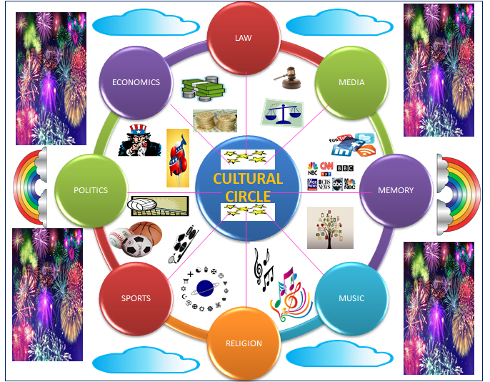

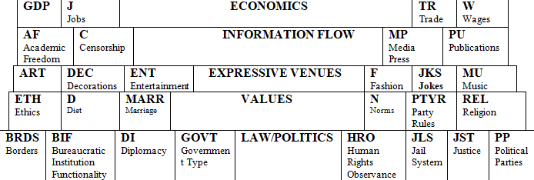

The Cultural Circle and Cultural Table of Elements was developed/created by David Monlux in the Fall 2018 Semester. Late one night he was procrastinating on his assignments (as all good students do) and being late to the disdain of some of his professors. During his procrastination he got a snack and sat down in front of the TV at 3 AM. The Lion King came on. During the movie he started reflecting on some of his previous high school/college classes. (American Cultural Experience, Anthropology of Language/Culture, Comparative Religions, Cuban Culture/Politics, Global Business Education, Diplomacy Lab II, Global Cultural Experience, International Political Economy, Intro to International Relations, Mexican Culture/Literature, Model UN, Practice of Diplomacy and World Regional Geography. In addition his time in Model Arab League combined with his five previous study Abroad experiences came into his memory all at once) Then the famous part of the Lion King (The Circle of Life) came on combined with the memory of a bar in Puebla Mexico that had a Periodic Table of Beer Styles and the Cultural Circle and Cultural Table of Elements was born. As any good inventor (Bill Gates, Mark Zuckerberg & Steve Jobs) for their field, Monlux skipped his classes the next day and spent all day developing this so future students in cultural studies would have an easier time learning basic concepts in the field. (Here is a photo that Periodic Table of Beer Styles Monlux took in that Puebla bar).

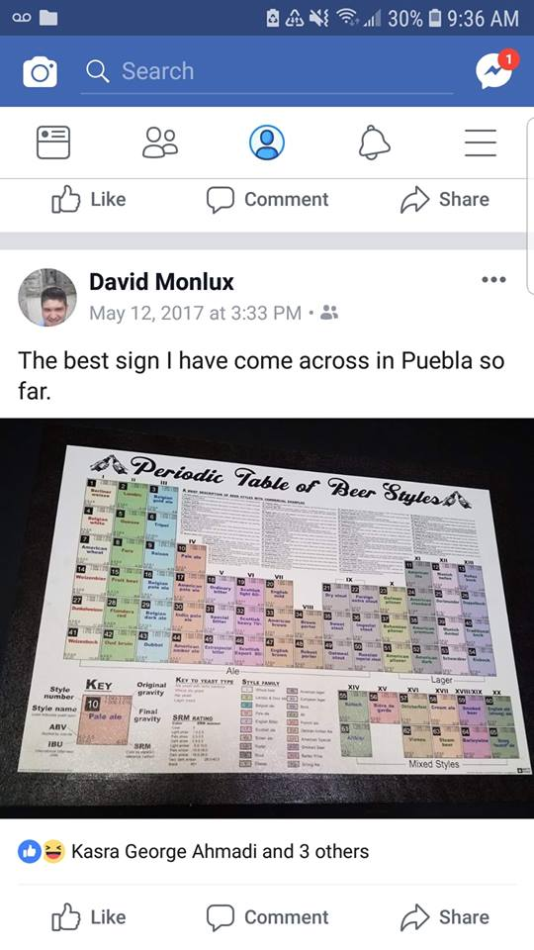

Going off the Cultural Circle and Cultural Table of Elements, they will be used as guides to measure seven (7) key areas. Five (5) come directly from the Circle and or Cultural Table of Elements while two (2) are variable not usually accounted for as an underlying tone in culture and values. They are the Architectural Space Design Layout, Climate/Geography, Economics, Expressive Venues, Information Flow, Law/Politics and Values. Below each will be examined and explored.

**Explanations, Details and Research:** Buy the book.

**CHAPTER 6: TERRORISM, ORGANIZED CRIMES & HUMAN RIGHTS: FEAR OF**

**JUSTICE, LIBERTY & ORDER FOR ALL:**

This chapter will cover 6 terrorist organizations, 8 major atrocities of human rights violations from the past and highlight 6 present day violations of human rights in mass still going on. It will then provide a chart summary of important major human rights documents and groups followed by present day scoring systems used to measure to human rights. The author will then offer up his views on what he believes the core fundamental 18 human rights for all should be followed by his own scoring system to better actually reflect the reality and situation on the ground. Then there will be an FAQ on the new proposed system of the author.

**TERRORIST, TERRORIST WHATCH GONNA DO WHEN THE INTERNATIONAL TASK FORCE COMES FOR YOU? TERRORIST!**

|  |  |
| --- | --- |
| TERRORIST ORGANIZATION/GROUP NAME: | DESCRIPTION: |
| The Black Standard of ISIL, which was adopted by Abu Sayyaf1: ABU SAYYAF GROUP (ASG): | **An Islamic separatist group that operates in the southern Philippines. The group split from the Moro National Liberation Front in the early 1990s under the leadership of Abdurajak Abubakar Janjalani, who died in a clash with Philippine police on December 18th, 1998. His younger brother, Khadaffy Janjalani, has replaced him as leader, although the modern day structure is composed of several semi-autonomous factions. Their activities include kidnappings for ransom, bombings, assassinations, and extortion. Despite their claim of a goal for an independent Islamic State in western Mindanao and the Sulu Archipelago, areas of the southern Philippines, ASG appears to primarily use terror tactics for financial profit. Their first large-scale operation was a raid on the town of Ipil in Mindanao in April 1995 and was followed up with an April 2000 kidnapping of 21 people, including 10 foreign tourists from a resort in Malaysia. That same year they also abducted several foreign journalists, 3 Malaysians and a US Citizen. On May 27th, 2001, the ASG kidnapped 3 US Citizens and 17 Filipinos from a tourist resort in Palawan, Philippines. Several of the hostages, including one US citizen, were murdered. They are also believed to be behind the January 27th, 2019 Jolo Cathedral Bombings in Jolo Town which resulted in the death of 18-20 (depending upon source) people and injured over 100 people.** |
| Flag of Jihad.svg2: AL-QA’IDA (AQ): | **Al-Qaeda overtime has mounted numerous attacks on government, civilian and military targets in various countries, including the 1998 United States embassy bombings, the US 9/11 attacks and the 2002 Bali bombings. The death of Osama bin Laden (Thank You Seal Team 6 & Obama) brought a change in the organizational structure that led al-Qaeda's operations to shift from the top down planning of attacks to lone wolf freelancers organized at the local group. Al-Qaeda illustrates suicide attacks and routine bombing of targets. Their training camps are believed to be in Afghanistan, Pakistan, Iraq and or Sudan. Their ideological goal is to remove of all foreign influences in Muslim countries, and the creation of a new caliphate ruling over the entire Muslim world. It actively works to promote the propaganda of a Christian–Jewish alliance attempting to destroy Islam which results to them believing a false justification for the religiously sanctioned killing of civilians, children and non-government personnel. It wants to implement a very strict form of Sharia Law. Al-Qaeda's leaders regard liberal Muslims, Shias, Sufis and other sects as heretics worthy of attack. Examples include the Yazidi community bombings, the Sadr City bombings, the Ashoura massacre and the April 2007 Baghdad bombings. Since the death of bin Laden in 2011, the group has been led by Egyptian Ayman al-Zawahiri.** |
| ShababLogo.png3: AL-SHABAAB: | **They began as an armed wing of the Islamic Courts Union (ICU), which later split into several smaller factions in 2006. The group describes itself as waging jihad against "enemies of Islam", and is engaged in combat against the Federal Government of Somalia and the African Union Mission to Somalia (AMISOM). The US Government has open bounties on several of the group's senior commanders which if your game to track them down might actually make college affordable or paying back those loans within reach. Al-Shabaab is a jihadi fundamentalist group based in East Africa. In August 2011, the Transitional Federal Government's troops and their AMISOM allies managed to capture all of Mogadishu controlled territory from al-Shabaab militants. An ideological dispute within the group's leadership caused several senior commanders to be assassinated. Al-Shabaab is also hostile to Sufi traditions and has had numerous clashes with the militant Sufi group Ahlu Sunna Waljama'a. By 2014 their troop numbers were estimated at somewhere between 7,000-9,000 militant fighters. In August 2014, Operation Indian Ocean was launched by the Somali government with the intention of wiping out the remaining al-Shabaab countryside held areas. On September 1st, 2014 a US drone strike killed al-Shabaab leader Ahmed Abdi Godane, aka Mukhtar Abu Zubair. Following that strike, the Somali government offered a 45-day amnesty certain members of this militant group. In 2015, al-Shabaab retreated from the major cities, but kept control of many large rural areas. They were also responsible for the Westgate Shopping Mall attack and the October 14th, 2017 Mogadishu Bombings. Al-Shabaab is still active today.** |
| Hamas logo.svgBoko Haram logo (2002â15).png4: BOKO HARAM: | **Boko Haram was founded by Mohammed Yusuf in 2002 which eventually led to uprisings that resulted in his 2009 execution. Their beginnings were nonviolent wanting to purify Islam in northern Nigeria. In 2009 Abubakar Shekau took over and has been running the organization like a boss ever since. An unexpected resurgence took place in September 2010, after a mass prison break/escape occurred. By 2011 they were attempting suicide bombings of police buildings and the Abuja UN office. Nigeria declared a state of emergency in early 2012, which extended into 2013. Of the 2.3 million people displaced by the conflict since May 2013, at least 250,000 have left Nigeria and fled to Cameroon, Chad or Niger. Boko Haram killed more than 6,600 Nigerians in 2014. The group carried out mass abductions including the kidnapping of 276 schoolgirls from Chibok in April 2014 which resulted in Michelle Obama’s famous hashtag #Bring Back Our Girls. In mid-2014, Boko Haram controlled large amounts of territory in the state of Borno, but failed to capture the state capital, Maiduguri. On March 7th, 2015, Boko Haram's leader Abubakar Shekau pledged allegiance to the Islamic State of Iraq and the Levant, rebranding as Islamic State in West Africa. Boko Haram were labeled the world's deadliest terror group by the Global Terrorism Index in 2015. In September 2015, the Director of Information at the Defence Headquarters of Nigeria announced that all Boko Haram camps had been destroyed. While territory is nonexistent, rebel militant groups in small numbers still make the occasional attack.** |
| Flag of Hamas.svg5: HAMAS: | **Formed in 1987 as an outgrowth of the Palestinian branch of the Muslim Brotherhood. HAMAS has used a combination of political and violent tactics/means, in an attempt to establish an Islamic Palestinian State with the goal of wiping out Israel. It’s base of power is the Gaza Strip and the West Bank. It has also run candidates in West Bank elections. It has also launched rockets at Israel, has pushed for hatred of Jews curriculum in Palestine, West Bank and Gaza Strip schools. HAMAS activities include large scale suicide bombings against Israeli civilian and military targets.** |
| Flag of Hezbollah6: HEZBOLLAH: | **Formed in 1982 in response to the Israeli invasion of Lebanon, this Lebanon based radical Shi’a group got its ideological inspiration from the Iranian Revolution and teachings of the Ayatollah Khomeini. It’s highest governing body is the Consultative Council. Hezbollah until recently in its public rhetoric has formally advocated for ultimate Islamic rule in Lebanon while calling for the liberation of what they view as all occupied Arab lands with Jerusalem being their top priority in addition to advocating for the destruction and elimination of Israel. In 1992, Hezbollah participated in parliamentary elections. They are allied with and rumored with very strong circumstantial evidence to be one of Iran’s political puppets with their orders coming directly from Tehran. In addition Hezbollah has been suspected of involvement in numerous anti-US terrorist attacks, including the Beirut April 1983 suicide truck bombings of the US Embassy and US Marine barracks in October 1983 along with the September 1984 US Embassy annex. The group also attacked the Israeli Embassy in Argentina in 1992 and is highly suspected of the 1994 Buenos Israeli Cultural Center bombing. Today Hezbollah is highly suspected of both sleeper cells and drug smuggling for profit in Venezuela while being in bed with the Nicolas Maduro government. (2/22/2019)** |

**8 ATTROCITIES OF PAST TO NEVER FORGET**

|  |
| --- |
| 1: ARMEANIAN GENOCIDE (1914-1923): The Armenian Genocide sometimes nicknamed the Armenian Holocaust was the Ottoman government's systematic extermination of 1.5 million Armenians within Ottoman Empire jurisdiction. Most scholars attribute the start date as April 24th, 1915 despite orders for it originally being written in 1914. On that day, Ottoman authorities rounded up, arrested, and deported 235 (confirmed) and an additional 35 rumored academic, intellectual and community leaders who disappeared or were never heard from again from Constantinople (Istanbul) to Ankara where most of them faced death. The genocide was committed during and after World War I with 2 phases (Mass killing of able-bodied men and the deportation of women and children on death marches to the Syrian Desert. On these marches the Armenians were deprived of food/water and subjected to routine beatings like the slaves of Egypt Moses had freed in the past. There was also rape, mass grave digging and many Armenians were robbed of their possessions. Many scholars and historians, recognize the Armenian Genocide as one of the first modern genocides because of its organized manner in which the killings were carried out. It is the second most-studied case of genocide after the Holocaust. Despite large amounts of pressure that it happened, Turkey has refused to recognize that it happened, claims it is a hoax and no one died and even if it was real that it occurred under a different country. To this day Armenia is attempting to seek recognition and compensation of restitution for the terrible and tragic crimes of genocide committed against the Armenian people. |
| 2: The BANGLADESH GENOCIDE started on March 26th, 1971 with Operation Searchlight from West Pakistan and Islamic militias (Jamaat-e-Islami) as the military cracked down on Eastern dissidents calling for an Independent Bangladesh. During the 9 months Bangladesh war for independence, members of the Pakistani military killed somewhere between 300,000-3,000,000 people. (Depends on which source(s) and how you define the deaths.) An additional 200-400k Bangladeshi women were publically raped according to Bangladeshi and Indian sources. This was a result of Muslim religious leaders declaring Bengali women to be gonimoter maal ("public property"). Most of those affected were Hindus who suffered terrible deaths and harm under Islamic extremist. An additional 8-10 million people, (mostly Hindus) fled to seek refuge in India. This genocide caused 30 million civilians to be internally displaced within Bangladesh, hurt the economy and caused many to loose property and be poor after the genocide was over creating vast levels of poverty and inequality within Bangladesh that exist to this day. |
| 3: CAMBODIAN GENOCIDE: The Cambodian genocide was led by the Khmer Rouge regime under the leadership of Pol Pot. Between 1975 and 1979 inflicting somewhere between 1.671-1.871 million people (21-24% percent of Cambodia’s population) loss their lives. The Khmer Rouge Regime had the motivation of turning Cambodia into a socialist agrarian republic with ultra-Maoism policies. In 1976, the Khmer Rouge Regime changed the name of Cambodia to Democratic Kampuchea. Like Hitler sent Jews to Concentration Camps in mass numbers, the Khmer Rouge Regime since suspected opposition Cambodians to countryside labor camps where mass executions, forced labor, physical abuse, malnutrition, and disease was commonplace. This wiped out 25% of Cambodia's total population. The most notorious prison under this regime was Tuol Sleng Centre (Security Prison S-21). Of the 20,000 anti-socialist Cambodians sent to S-21 only 7 adults survived. Killing Fields where opponents were executed was common. Instead of bullets or gas chambers, most were tied up where they couldn’t move and then slowly and brutally killed with pickaxes before being buried in mass graves. This regime also took part in mass abduction and indoctrination of children while forcing them to commit atrocities and providing them with false justifications of comfort for their actions. Many of additional Cambodians escaped to Vietnam and Thailand. Tired and fed up of hosting refugees, Vietnam then invaded Cambodia to end the genocide and the Khmer Rouge Regime in 1979. On January 2nd, 2001, the Cambodian government established the Khmer Rouge Tribunal, to try the members of the Khmer Rouge Regime responsible for the Cambodian genocide. The first Trial finally took place on February 17th, 2009. On 7 August 2014, Nuon Chea and Khieu Samphan were convicted and sentenced to life in prison for crimes against humanity for their role in the Cambodian genocide. As of 2009, the Cambodian NGO Documentation Center of Cambodia has mapped 23,745 mass graves containing 1.3 million suspected victims of execution. Many additional Cambodians suffered starvation, shortages of good and suffered greatly during this genocide. |
| 4: EAST TIMOR (TIMOR LESTE) GENOCIDE: It started in August 1975 when Indonesian (TNI) forces engaged in the massacre of Timorese civilians. At the start of the occupation, FRETILIN radio sent the following broadcast: "The Indonesian forces are killing indiscriminately. Women and children are being shot in the streets. We are all going to be killed.... This is an appeal for international help. Please do something to stop this invasion." These troops then went into Dili. Martinho da Costa Lopes (Dili’s Bishop) said "The soldiers who landed started killing everyone they could find. There were many dead bodies in the streets – all we could see were the soldiers killing, killing, killing." In one incident, a group of 50 people (including children and Australian freelance journalist Roger East ) were lined up on a cliff outside of Dili and shot before being thrown into the Sea. Many more massacres took place in Dili while civilians were rounded up against their will, forced to watch the executions and then count out loud as each person was executed. 2,000 Timorese were massacred in the first two days of the invasion in Dili. FRETILIN supporters and Chinese migrants were intentionally singled out for execution. Indonesian forces continued to advance on the Fretilin-held mountain regions of East Timor. In February 1976 after capturing the village of Aileu and driving out the remaining Fretilin forces, Indonesian troops machine gunned most of the town's population, regardless of age. Aileu then fell to Indonesian forces. The population went from 5,000 to less than 1,000 by the time Indonesian relief workers visited the village in September 1976. In June of 1976, TNI troops attacked large refugee camp housing 5-6k Timorese at Lamaknan near the West Timor border and then killed them followed by setting all houses in a neighboring village on fire. 2k died from those specific fires. In March 1977 ex-Australian consul James Dunn published a report stating that in 1975 and 1976, Indonesian forces killed 50-100k civilians in East Timor which confirmed the February 13th, 1976 statement by UDT leader Lopez da Cruz that 60k Timorese had been killed during the previous 6 months. A late 1976 report by the Catholic Church estimated the death toll between 60-100k. Rather then deny that the deaths took place, on April 5th, 1977 the Indonesian Government itself claimed responsibility for the deaths via an interview with the Sydney Morning Herald in which Indonesian Foreign Minister Adam Malik said the number of dead was "50,000 people or perhaps 80,000". The Indonesian government excuse/justification spin was a weak argument of anticolonial unity in which they published a 1977 booklet from the Indonesian Department of Foreign Affairs, called *Decolonization in East Timor*, paid tribute to the "sacred right of self-determination" recognizing APODETI as the true representatives of the East Timorese majority. It claimed that FRETILIN's popularity was the result of a "policy of threats, blackmail and terror". In 2006 Indonesian Foreign Minister Ali Alatas reaffirmed his position by writing his memoir *The Pebble in the Shoe: The Diplomatic Struggle for East Timor.* The island's original east/west division as argued by Indonesia after the invasion, was "the result of colonial oppression" enforced by the Portuguese and Dutch imperial powers with the Catholic Church being implicit. Thus, according to the Indonesian government, its annexation of the 27th province was merely another step in the unification of the archipelago which had begun in the 1940s and was necessary. However many claim it was a religious war since the majority of the victims were Christian or Chinese and many Muslims who professed Allah to troops were spared. |
| 5: HOLOCAUST was a genocide in which Nazi Germany systematically murdered 6 million European Jews (2/3 of Europe’s Jewish population) between 1941-1945 during World War II. An additional 11 million people from the Slavs, Polish, Soviets, the Roma, the disabled, political opponents, Jehovah's Witnesses, members of the LGBTQ community and academics were also killed and sent to these camps resulting in over 17 million overall deaths of deliberate systematic persecution separate from War fighting deaths. The planning started with Hitler's rising to power in 1933 in which his Nazi government took steps to exclude Jews from civil society, which included organizing a boycott of Jewish businesses and passing the Nuremberg Laws in 1935. Also in 1933, the Nazis started building a network of concentration camps in Germany for political opponents and people deemed "undesirable". After the invasion of Poland in 1939, the regime set up ghettos to segregate Jews. Over 42,000 camps, ghettos, and other detention sites were established across Nazi controlled Europe. Jews were sent to these ghettos and concentration camps under an extermination policy that the Nazis nicknamed the "Final Solution to the Jewish Question", implemented by senior Nazi officials at the Wannsee Conference in Berlin of January 1942. As German forces captured territories in the East, all anti-Jewish measures and policy increased in absurdity, intensity and frequency. Under the coordination of the Gestapo directed by leadership of the Nazi Party, killings were committed within Germany, Nazi controlled/occupied Europe and all Axis Powers territories. Death squads known as Einsatzgruppen in cooperation with Wehrmacht police battalions murdered about 1.3 million Jews in mass shootings between 1941 and 1945. The Concentration Camps themselves had terrible sanitation conditions, terrible medical care, had people working 16-20 hours (depending on camp/job) a day 7 days a week, had no time set aside for religious observance, many were subject to routine beatings and raped along with the infamous gas chambers that many unknowingly went to their death. The killings and these Concentration Camps combined with persecution against the Jews continued in Europe until the end of World War II in May 1945. |
| 6: PINOCHET came to power in Chile on September 11th, 1973 overthrowing the democratically elected Unidad Popular government of Chilean President Salvador Allende which ended civilian rule after being promoted to General Chief of Staff on August 23rd, 1973. In December 1974, the ruling military junta appointed Pinochet Supreme Head of the nation by joint decree. Following his rise to power, Pinochet persecuted leftists, socialists and political critics resulting in the death of 1,200-3,200 Chileans. He also illegally imprisoned 80,000 people subjecting them to terrible and undescribed torture. An additional 3,095 forced disappearances took place to which those people are still unaccounted for to this day. The people he did this to opposed the free market-oriented neoliberal "Chicago Boys", economic liberalization and currency stabilization policies which removed tariff protections for local industry, banned trade unions and privatized both social security and many state-owned enterprises resulting in high unemployment and large layoffs. This led to mass poverty, soup kitchens, food shortages and inflicted suffering initially via shock therapy. Despite Chile having the best economy in Latin America of the 1990’s under Pinochet’s rule, it couldn’t make up for the loss of life and mass torture of citizens in anyway that took place earlier during his rule in the 1970’s and 1980’s. In a 1988 vote, 56% voted against Pinochet's continuing as President, which led to democratic elections for the presidency and Congress. After stepping down in 1990, Pinochet continued to serve as Commander-in-Chief of the Chilean Army until March 10th, 1998, when he became a senator-for-life. On October 10th, 1998 Pinochet was arrested on an international arrest warrant during a London visit of October 10th, 1998 for a large number of human rights violations. Following a legal battle, he was released on medical grounds and returned to Chile on March 3rd, 2000. In 2004, Chilean Judge Juan Guzmán Tapia ruled Pinochet was medically fit for trial and put him on house arrest. When he died on December 10th, 2006, 300 criminal charges for human rights violations were still pending against him. |
| 7: The RWANDAN GENOCIDE was a mass slaughter of Tutsi (70% of population killed) and Pygmy Batwa (30% of population killed) in Rwanda during the Rwandan Civil War that started in 1990. It was arranged and carried out by members of the Hutu majority government between April and July of 1994. Most of the Rwandan Genocide organizers were members of the Hutu political elite. An estimated 500,000 to 1,000,000 Rwandans were killed. The genocide of the Tutsi’s and Pygmy Batwa’s ended after the Rwandan Patriotic Front (RPF), led by Paul Kagame took control of Rwanda and its capital. An addition 2,000,000 Rwandans were displaced and became refugees. The triggering point or excuse claimed by the Hutu’s was 6th, 1994, when an airplane carrying Habyarimana and Burundian President Cyprien Ntaryamira was shot down over Kigali. The very next day, the genocide began.  The genocide had major effects on Rwanda and neighboring countries. The rapes used as a war weapon increased the number of people infected with HIV infection, including babies born to mothers infected by the rapes. Many Rwandan households were widows or only orphaned children. The destruction of infrastructure and the severe depopulation of the country crippled the economy leading to economic struggles and instability. Large numbers of Hutu’s who took no place in the genocide and actually opposed it but remained silent of fear fled Rwanda and became refugees in the eastern portion of Zaire (Democratic Republic of the Congo (DRC)). These refugees put strains on neighboring host governments, deprived Rwanda of more capital and increased tensions resulting in armed struggles between the Rwandan government and Hutu’s in the DRC via proxy battles in the Goma region, including the 2012-2013 M23 rebellion. Large numbers of Rwandan Hutu and Tutsi populations continue to live as refugees throughout Africa. As a result of the Rwandan Genocide, the International Criminal Court was allowed to prosecute genocide, crimes against humanity and war crimes. |
| 8: The YAZIDI GENOCIDE took place in August 2014. The Islamic State (ISIL/ISIS) committed mass atrocities against the Yazidis in Iraq. It resulted in 4,400 deaths and was nicknamed the Sinjar Massacre. While most of the killed were men, an additional 10,800 Yazidi women and children were enslaved against their will becoming slaves. Many of the women were sexually abused on a regular basis during their slavery. Some are still enslaved by ISIS/ISIL against their will today. Thousands of additional Yazidis fled to avoid the forced conversion and massacre campaigns, thus making them defacto refugees. In addition to thousands of deaths and additional thousands enslaved by ISIL/ISIS, the refugee number for the Yazidis is now at 500k leaving them displaced and denied rights to their ancestral homeland in some of the most egregious ever recorded human rights violations. |

**6 PRESENT DAY HUMAN RIGHTS VIOLATIONS**

|  |
| --- |
| 1: CHINESE MUSLIM DETENTION CAMPS: The Muslim minority of the Uyghurs and Kazakhs ethnic groups have found themselves the victims of targeting in modern day China of what most people would call massive modern day Human Rights Violations. Anywhere between 500k-2 million (depending upon source with most saying 1 million) Uyghurs and Kazakhs Muslims have been disappeared and held against their will without trial, attorneys, due process, warrants and or formal government charges. The primary area where this is taking place is Xinjiang Province in China. According to an in depth BBC investigative report[[83]](#footnote-83) in July 2015 at the site known as Dabancheng the land went from nothing to a satellite image. By April 2018 via satellite imagining they were able to prove the existence of a mass structure that looks like a camp. Questions to the Chinese government went unanswered. Using Sentinel Images in October 2018, the BBC saw the site even more developed. That same BBC report also has an interview with Ablet Tursun Tohti who survived the camps and was let out. In that interview he described being woken up early every day, forced to run, sing Communist Chinese songs and then indoctrinated with Chinese values. Whoever couldn’t recite them word for word after being told the first time was beaten until they learned. China’s response is that these mislabeled camps are vocational educational centers in which these people are taught Mandarin Chinese like a language immersion camp and include luxurious dorms. In addition they are given vocational training for jobs that will make a living while being paid and allowed to save that money for when they voluntarily reenter society. In addition Chinese state run TV (CCTV 13) released two images of what they claim is a happy classroom and one of the sowing centers used for textile jobs.  https://static01.nyt.com/images/2018/12/17/world/17xinjiang-labor1/merlin_148213692_0d79ec0d-c129-4886-9ab0-1a8f8723d82a-articleLarge.jpg?quality=75&auto=webp&disable=upscale https://static01.nyt.com/images/2018/12/17/world/17xinjiang-labor4/merlin_148213620_2f309a14-7800-4dd0-b60f-06477a77ba47-articleLarge.jpg?quality=75&auto=webp&disable=upscale[[84]](#footnote-84)  Just like many Universities in Latin America are autonomous, have security check points and run their own area while having walls around the main outer areas of the campus, so do these camps/vocational education centers in China. Critics point out and claim that visitation rights are denied, there are no records of formal applications or acceptance letters and that most people allegedly at these centers are there longer than normal length academic program while not even having semester/quarter breaks to go home. The evidence mounted in 2018 with an Amnesty International detailed 22 page report[[85]](#footnote-85) which includes interviews with family members of detained individuals. It also includes testimony of detainee Kairat Samarkan with a drawing from memory about one of the many tortures endured. Page 10 of that report implements the no rights zone that has been implemented (US equivalent would be suspension of habeas corpus) throughout the Xinjiang Province. Going further to look at what causes people to be detained verses not, Anthropology Department PhD University of Washington Researcher Darren Byler submitted a 10 page policy brief[[86]](#footnote-86) to the Canadian Parliament House of Commons. His findings found that foreign contacts were fine so long as they didn’t come from a specific set of 26 countries in which he cites a 2017 Wall Street Journal Article Journal appendix[[87]](#footnote-87) and also revealed dress codes being enforced and mandated by the government. One way to describe the dress code is how Jews were made to wear the star in Nazi controlled Germany to identify their religion to be targets. In this case, the Muslims of these ethnic groups are prevented from wearing beards, head scarves and logos of the crescent moon and stars otherwise they are singled out for wearing things of faith. The primary form of evidence presented is figures 3 and 1.    Despite the controversy and competing theories what is clear is that in the past the Chinese government has had reeducation camps and history repeats itself many times. In addition a large number of Uyghurs and Kazakhs Muslims in the Chinese Xinjiang Province have whereabouts unknown (Chinese Government)/suspected (Camps according to critics) while not being in contact with others, families want to know where their loved ones are and a large portion of the minority populations are living in fear. Based off publically available evidence there is a high probability that the circumstantial evidence of illegal detention, abuse, torture and indoctrination of Communist ideology is taking place with deliberate religious and ethnic targeting by a well-organized machine of functionality that is China. |
| 2: MYANMAR ROHINGYA MUSLIMS: While most of the World started paying attention to this tragedy and mass abuse of human rights potentially bordering on ethnic cleansing in August 2017, the struggle has been much longer than that. In order to understand how the poor conditions and atrocities came about one has to go back to 1948. In the 1948 Constitution of Burma (Myanmar) the Rohingya Muslims were considered citizens and had full rights despite the majority religion being Buddhism. In 1962 a coup took place in Burma (Myanmar) and downgraded the Rohingya’s to legally permeant residents. The 1974 Constitution didn’t recognize the Rohingya at all. Then the Citizenship Act of 1982 was enacted, which stated that citizens must belong to one of 135 'national races' as recognized under the constitution, or whose ancestors settled in the country before 1823.[[88]](#footnote-88) This brings up and creates an interesting dispute of when the Rohingya settled in the country to determine if they are indigenous or not. The Myanmar Government views the Rohingya Muslims as illegal immigrant squatters from Bangladesh that came over during British Colonial Administration rule. The Buddhist Nationals see the Rohingya as illegal immigrant Muslims stealing jobs while the Rohingya claim they have ancestors going back centuries. Attacks on the Rohingya were limited until 1978 which started a series of 5 major attacks through August 2017.  [[89]](#footnote-89)  Of note there was a break of stability between the mid 1990’s until 2012. During that time the Rohingya Muslims were issued what became known as white cards defining them as temporary residents with limited rights including the right to vote.[[90]](#footnote-90) These elections included the 2008, 2010 and 2015 elections, however foreshadowing took place in 2015 not a single Muslim candidate was allowed on the ballot. In 2016 there were small scale attacks that caused 87,000 Rohingya Muslims to flee into Bangladesh. A calm before the storm would ensue and then the events that got the attention of the international community in mass unfolded in August of 2017. It was a calm peaceful morning on August 25th, 2017 in a Rohingya Muslim village when a Buddhist mob, Myanmar Government forces or possibly a combination of both (depending upon the source) entered a village and started burning it to the ground. BBC journalist talking to Medecins Sans Frontieres (Doctors Without Borders)[[91]](#footnote-91) stated that 6,700 people were killed including 730 children under the age of 5. In the days that would follow thousands of additional Rohingya’s would die. In addition as hundreds of thousands fled for the border, multiple unconfirmed but highly probable rumors went around that the Myanmar Military rigged the border area with landmines. With increasing international pressure and demands for answers, the government of Myanmar finally made an official announcement on September 5th, 2017 in which they stated chaos had been in the area. Rebel militants wanting to overthrow the government that happened to be Rohingya’s were killed resulting in 400 deaths and announced the end of operations. However rumors continued of ethnic cleansing and China using its Permeant 5 Security Veto blocked Sanction on Myanmar citing Soveginity and territorial integrity protection from threats. In addition UN inspectors were blocked and prevented from entering along with journalist. The most recent verified data on the number of Rohingya Muslims in Bangladesh at the time of submission to the publisher is as follows:  [[92]](#footnote-92) |
| 3: NORTH KOREAN DICTATORSHIP OF KIM JONG UN: Buy the book. |
| 4: SAUDI ARABIA: EVADING JUSTICE ABROAD, MURDERING JOURNALIST & DENYING WOMEN BASIC RIGHTS: Buy the book. |
| 5: TURKEY’S HUMAN RIGHTS ABUSES UNDER ERDOGAN SINCE THE FAILED “COUP”: Buy the book. |
| 6: VENEZUELA UNDER NICOLAS MADURO: Buy the book. |

Major Human Rights Documents, Current Human Rights Advocacy/Watch Dog Groups, Current Human Rights Scoring Systems/Measurements, Monlux View on Human Rights, New Proposed Human Rights Scoring System & FAQ’s: **BUY THE BOOK.**

**CHAPTER 7: LOCO MOTION & CHA CHA SLIDE OF NATIONS MEANT TO FLY**

**NATION TRIANLGE & ELEMENTAL TABLE OF NATIONHOOD**

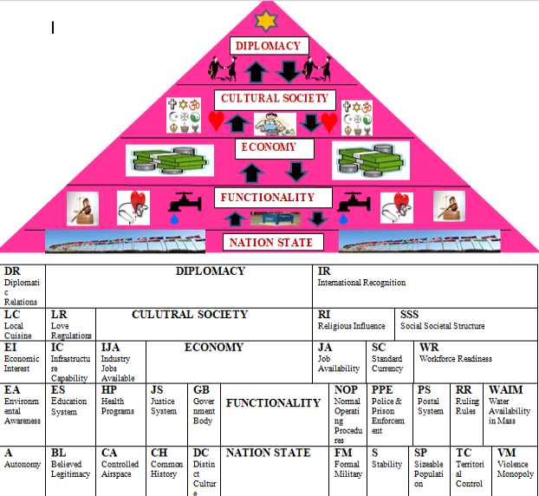

Nation Formation & Deformation, Monlux Scoring System to Define Nation Status, Examples, Rankings, Explanations & FAQ’s: **BUY THE BOOK**

**CHAPTER 8: GOOD RIDDANCE STATIONARY LIFE: STUDYING ARBOAD ITS EXPEREINCES UNDPREDICTABLE BUT IN THE END IS RIGHT YOU’LL HAVE THE TIME OF YOUR LIFE:**

**SECTION 1: ANYWAY YOU WANT IT TO WHERE?**

Below is what one should considering when picking a study abroad program.

Academics: Is this required for my degree? How will this benefit/compliment/advance my education?

Funding: How will I pay for the program fee? How will I pay for my transportation there and back? Will I have multiple forms/sources of money? What is the cost of living like in the area I will be traveling to/living in for the Semester?

Health: Am I healthy enough to go abroad? How does the local health care system work should I need to access it? Do I have travel insurance? If I’m on medication is it legal in my country destination(s)? What are the requirements to get prescriptions dispensed at the local pharmacy? Is the medication cost the same, cheaper or more expensive than my country?

Career Opportunities/Advancements: Will this help or benefit my career? Will my future employer have operations in this area? Will I have to deal with a large number of people from this area during my job/career? Will this help me with employers?

Language: Do I know the language before I go or will I learn it in country/region? Would everyday exposure complement my learning style to help me pick up the language? What opportunities does learning this language give me for jobs/careers with future employers? Is my stay long enough to really learn the language?

Cultural Immersion: Am I ok with the value set and local customs of the culture I’m heading to? How do I deal with change and new scenery? What will the change in living conditions be like? Is there anything that I need to alter my wardrobe for? If I disagree with the local customs, how will I cope or avoid partaking in them without offending the locals?

Personal Goals/Motivation: Is this for me or to honor a memory of someone? Is it to meet your long lost family? Is there a historical/tourist site that you’ve always wanted to visit in country and this study abroad justifies my side excursion(s)? Why am I going? What do I hope to get out of this? Is it to prove someone/something wrong? Is it to avoid/runaway from something?

Every individual is unique with their own path/career plans. Using the formula/questions above along with other considerations, it can help determine the right study abroad destination/program for you.

**SECTION 2: THAT’S THE WAY UH HUH UH HUH I LIKE**

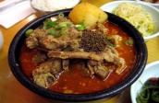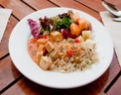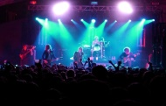C:\Program Files (x86)\Microsoft Office\MEDIA\CAGCAT10\j0185604.wmfC:\Program Files (x86)\Microsoft Office\MEDIA\CAGCAT10\j0185604.wmf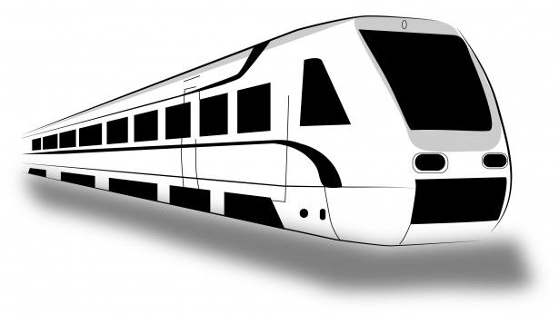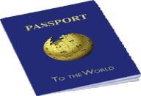

**SECTION 3: HEALTH & SAFTEY CONCERNS**

**\_\_\_\_\_\_\_\_\_\_\_\_\_\_\_\_\_\_\_HEALTH\_\_\_\_\_\_\_\_\_\_\_\_\_\_\_\_\_\_\_\_\_\_\_\_\_\_\_\_\_\_SAFTEY\_\_\_\_\_\_\_\_\_\_\_**

**SECTION 4: EXPEREINCES OF MONLUX ABROAD:**

To read about the study abroad trips of David Monlux during his undergraduate studies in the countries of Turkey, Greece, Mexico, Cuba and Peru, but the book.

**CONCLUSION**

To read the conclusion, please buy the book.

**WORKS CITED & PICTURE REFERENCES:**

Will be included in the Final Book

1. <https://www.upaep.mx/> [↑](#footnote-ref-1)
2. Sherlock Holmes [↑](#footnote-ref-2)
3. Ghost of Christmas Past Scrooge A Christmas Carrol [↑](#footnote-ref-3)
4. A Few Good Men: **“You Can’t Handle the Truth”** [↑](#footnote-ref-4)
5. Fun We Are Young featuring Janelle Monáe **“We are young So let’s set the World on Fire We can burn brighter”** [↑](#footnote-ref-5)
6. Rihanna Diamonds [↑](#footnote-ref-6)
7. The Clash [↑](#footnote-ref-7)
8. Tyga - Far Away ft. Chris Richardson [↑](#footnote-ref-8)
9. Laozi Tao Te Ching [↑](#footnote-ref-9)
10. Hamlet: Act III: Scene I: Shakespeare [↑](#footnote-ref-10)
11. Hamlet: Act III: Scene I: Shakespeare [↑](#footnote-ref-11)
12. KE$HA [↑](#footnote-ref-12)
13. Paraphrase addition of the US Pledge of Allegiance [↑](#footnote-ref-13)
14. Inner Circle Bad Boys [↑](#footnote-ref-14)
15. Little Eva [↑](#footnote-ref-15)
16. DJ Casper [↑](#footnote-ref-16)
17. Nicki Minaj Starships Were Meant to Fly [↑](#footnote-ref-17)
18. Time of Your Life/Good Riddance Green Day [↑](#footnote-ref-18)
19. Journey [↑](#footnote-ref-19)
20. KC and the Sunshine Band [↑](#footnote-ref-20)
21. Paraphrase of Julius Caesar Veni, Vidi, Vici Latin for I Came, I Saw, I Conquered [↑](#footnote-ref-21)
22. Europe [↑](#footnote-ref-22)
23. Buzz Lightyear [↑](#footnote-ref-23)
24. Nelly Just a Dream [↑](#footnote-ref-24)
25. The Price is Right Game Show on CBS <https://www.cbs.com/shows/the_price_is_right/> Accessed and viewed March 9th, 2019, however as a kid when I was sick and during the Summer I would watch the show regularly. [↑](#footnote-ref-25)
26. Tinie Tempah Written in the Stars ft. Eric Turner [↑](#footnote-ref-26)
27. Queen We Will Rock You [↑](#footnote-ref-27)
28. 1996 Film [↑](#footnote-ref-28)
29. 1992 Film [↑](#footnote-ref-29)
30. Kesha [↑](#footnote-ref-30)
31. Al Gore [↑](#footnote-ref-31)
32. Black Eye Peas “Lets Get it Started” [↑](#footnote-ref-32)
33. Joan Jett I Love Rock n' Roll: [↑](#footnote-ref-33)
34. Bob Seger Old Time Rock n Roll [↑](#footnote-ref-34)
35. Star Trek [↑](#footnote-ref-35)
36. Star Wars [↑](#footnote-ref-36)
37. Star Trek [↑](#footnote-ref-37)
38. Pokémon [↑](#footnote-ref-38)
39. Brave New World [↑](#footnote-ref-39)
40. Drogus Ann Carol and Orvis Stephen: *Introducing Comparative Politics; Concepts and Cases in Context* 2nd Edition: Sage & CQ Press: ISBN #978-1-60871-668-5 [↑](#footnote-ref-40)
41. Barrington Lowell *Comparative Politics: Structures and Choices* 2nd Edition Wadsworth Cengage Learning: ISBN #978-1-111-34193-0 [↑](#footnote-ref-41)
42. Dickovick Tyler J. and Eastwood Jonathan *Comparative Politics: Integrating Theories, Methods and Cases* 2nd Edition: Oxford University Press ISBN #978-0-19-027099-5 [↑](#footnote-ref-42)
43. Rickards James *Currency Wars: The Making of the Next Global Crisis* Portfolio Penguin ISBN #978-1-59184-556-0 [↑](#footnote-ref-43)
44. US Secretary of State Hillary Clinton: *Hard Choices a Memoir* Simon & Schuster Hard Cover Edition 2014: ISBN #978-1-4767-5144-3 [↑](#footnote-ref-44)
45. Dorman Shaw Editor *Inside a U.S. Embassy Diplomacy at Work The Essential Guide to the Foreign Service* All New 3rd Edition Foreign Service Books: American Foreign Service Association ISBN #978-0-9649488-4-6 [↑](#footnote-ref-45)
46. Gillespie A Charles and Kopp W Harry *Career Diplomacy: Life and Work in the US Foreign Service* 2nd Edition Georgetown University Press Washington DC ISBN #978-1-58901-740-5 [↑](#footnote-ref-46)
47. Bailey A Thomas *A Diplomatic History of the American People* 7th Edition Appleton Century-Crofts: Division of Meredith Publishing Company New York US Library of Congress Card Number 64-10909 [↑](#footnote-ref-47)
48. US Secretary of State Condoleezza Rice *No Higher Honor: A Memoir of My Years in Washington* Broadway Paperbacks, Imprint of Crown Publishing Group Division of Random House Publishing Parent Company Penguin Group ISBN #978-0-307-98678-8 [↑](#footnote-ref-48)
49. Rodrik Dani *The Globalization Paradox: Democracy and the Future of the World Economy* W.W. Norton and Company ISBN #978-0-393-34128-7 [↑](#footnote-ref-49)
50. Raymond A Gregory and Kegley Jr. W. Charles *The Global Future: A Brief Introduction to World Politics* 4th Edition Wadsworth Cengage Learning Copyright 2006, 2010 and 2012 ISBN #978-0-495-89866-5 [↑](#footnote-ref-50)
51. Bhagwati Jagdish *In Defense of Globalization* Council on Foreign Relations Book: Oxford University Press: ISBN #978-0195-170252 [↑](#footnote-ref-51)
52. Grillot R Suzette and Messitte P Zach *Understanding the Global Community* University of Oklahoma Press ISBN #978-0-8061-4338-5 [↑](#footnote-ref-52)
53. Edmondson-Poli Emily and Shirk A. David *Contemporary Mexican Politics* Roman & Littlefield Publishers Inc ISBN #978-0-7425-4049-1 [↑](#footnote-ref-53)
54. Kenney D. Charles *Fujimori’s Coup and the Breakdown of Democracy in Latin America* University of Notre Dame Press and the Hellen Kellogg Institute for International Studies ISBN #978-0268-03172-5 [↑](#footnote-ref-54)
55. Hernandez-Rodriguez R. ABC-CLIO, LLC ISBN #978-0-313-34977-5 [↑](#footnote-ref-55)
56. Mesa-Lago Carmelo and Lopez-Perez Jorge *Cuba’s Aborted Reform* University Press of Florida in cooperation with the Cuban Research Institute at Florida International University ISBN #0-8130-2868-X [↑](#footnote-ref-56)
57. Green N James, Smith H Peter and Skidmore E Thomas *Modern Latin America* 7th Edition Oxford University Press ISBN #978-0-19-537570-1 [↑](#footnote-ref-57)
58. Moaveni Azadeh *Lipstick Jihad A Memoir of Growing Up Iranian in American and American in Iran* Public Affairs Member of the Perseus Books Group ISBN #978-1-58648-378-4 [↑](#footnote-ref-58)
59. Chahin M *The Kingdom of Armenia* Dorset Press of Marboro Books Cooperation arranged with Routledge ISBN #978-0880-29609-0 [↑](#footnote-ref-59)
60. Shafik Viola *Arab Cinema History and Cultural Identity New Revised Edition* The American University in Cairo Press ISBN #978-977-416-065-3 [↑](#footnote-ref-60)
61. Grenier M. Stephen and Mattox A. Gale Editors *Coalition Challenges in Afghanistan : The Politics of Alliance* Stanford University Press ISBN #9780804794442 [↑](#footnote-ref-61)
62. Cleveland L William *A History of the Modern Middle East* 3rd Edition Westview Press ISBN #978-0-8133-4048-7 [↑](#footnote-ref-62)
63. Satrapi Marjane *The Complete Persepolis* Pantheon Books ISBN #978-0-375-71483-2 [↑](#footnote-ref-63)
64. Lust Ellen *The Middle East* 12th Edition CQ Press ISBN #978-1-60426-548-4 [↑](#footnote-ref-64)
65. Smith D. Anthony *National Identity* University of Nevada Press ISBN #978-0874-17204-1 [↑](#footnote-ref-65)
66. Gellner Ernest *Nations and Nationalism* Cornell University Press ISBN #978-0801-49263-4 [↑](#footnote-ref-66)
67. Anderson Benedict *Imagined Communities* Verson ISBN #978-0860-91576-1 [↑](#footnote-ref-67)
68. US Secretary of State Henry Kissinger *World Order* Penguin Books ISBN #978-0-14-312771-0 [↑](#footnote-ref-68)
69. Bertsch K Gary, Grillot R Suzette and Nunn Sam *Arms on the Market Reducing the Risk of Proliferation in the Former Soviet Union* ISBN # 978-0415920582 [↑](#footnote-ref-69)
70. Mittal Sushil and Thursby Gene Editors *Religions of South Asia an Introduction* Routledge ISBN #978-0-415-22391-1 [↑](#footnote-ref-70)
71. Lenardon J. Robert, Morford P.O. Mark and Sham Michael *Classical Mythology* 9th Edition Oxford University Press ISBN #978-0-19-539770-3 [↑](#footnote-ref-71)
72. Brodd Jeffrey and Sobolewski L. Gregory *World Religions A Voyage of Discovery* 3rd Edition Saint Mary’s Press ISBN #978-0-88489-997-6 [↑](#footnote-ref-72)
73. Rhodes Ron *The Complete Guide to Christian Denominations Understanding the History, Beliefs and Differences* Harvest House Publishers ISBN #978-0736-91289-1 [↑](#footnote-ref-73)
74. Donaldson H Robert and Nocee L. Joseph *The Foreign Policy of Russia Changing Systems, Enduring Interest* 3rd Edition M.E. Sharpe Inc ISBN #978-0765-615688 [↑](#footnote-ref-74)
75. BBC World News: October 22nd, 2018: *Khashoggi Death: Saudi Arabia says Journalist was Murdered* <https://www.bbc.com/news/world-middle-east-45935823> Accessed February 13th, 2019 [↑](#footnote-ref-75)
76. Wendt Alexander <http://www.guillaumenicaise.com/wp-content/uploads/2013/10/Wendt-Social-Theory-of-International-Politics.pdf> Accessed and viewed on March 10th, 2019 [↑](#footnote-ref-76)
77. <http://seas3.elte.hu/coursematerial/LojkoMiklos/Alexis-de-Tocqueville-Democracy-in-America.pdf> [↑](#footnote-ref-77)
78. <https://msuweb.montclair.edu/~lebelp/DownsEcThDemocJPE1957.pdf> [↑](#footnote-ref-78)
79. <https://pdfs.semanticscholar.org/6d10/3c50ce2912497a31639043e6e6f26e080e29.pdf> [↑](#footnote-ref-79)
80. <https://pdfs.semanticscholar.org/d2cd/d63e2aadce459af0eeb6a93e338bdd4984e8.pdf> [↑](#footnote-ref-80)
81. <http://www.sanghiya.com/wp-content/uploads/2012/10/Donna_Lee_Van_Cott_From_Movements_to_Parties_in_Latin_America.pdf> [↑](#footnote-ref-81)
82. <http://fordhamlawreview.org/wp-content/uploads/assets/pdfs/Vol_75/Graber_November.pdf> [↑](#footnote-ref-82)
83. Long Kathy and Sudworth John October 24th, 2018 *China’s Hidden Camps: What’s Happened to the Vanished Uighurs of Xinjiang* BBC World News <https://www.bbc.co.uk/news/resources/idt-sh/China_hidden_camps> Accessed Feb 18th, 2019 [↑](#footnote-ref-83)
84. Chinese State Run TV CCTV 13 Part of an official public press release for redistribution [↑](#footnote-ref-84)
85. Amnesty International *2018 China Where are They? Time for Answers About Mass Detentions in the Xinjiang Uighur Autonomous Region* [*https://www.amnesty.org/download/Documents/ASA1791132018ENGLISH.PDF*](https://www.amnesty.org/download/Documents/ASA1791132018ENGLISH.PDF) Accessed Feb 18th, 2019 [↑](#footnote-ref-85)
86. Byler Daren PhD University of Washington Anthropology Department October 23rd, 2018: *Uyghur Human Rights Violations in Northwest China* submitted to the Canadian House of Commons and considered official public record and part of the public domain <https://www.ourcommons.ca/Content/Committee/421/SDIR/Brief/BR10230024/br-external/BylerDarren-e.pdf> Accessed February 18th, 2019 [↑](#footnote-ref-86)
87. How he cited it in his public record submission to the Canadian House of Commons. The actual article was behind a pay wall and as a struggling college student, I couldn’t afford the subscription fee: Chin, Joshua. (2017). “Twelve Days in Xinjiang: How China’s Surveillance State Overwhelms Daily

    Life.” Wall Street Journal. <https://www.wsj.com/articles/twelve-days-in-xinjiang-how-chinassurveillance-state-overwhelms-daily-life-1513700355> [↑](#footnote-ref-87)
88. Minority Rights Group International, *World Directory of Minorities and Indigenous Peoples - Myanmar/Burma : Muslims and Rohingya,* October 2017, available at: <https://www.refworld.org/docid/49749cdcc.html> Accessed February 20th, 2019 [↑](#footnote-ref-88)
89. Abedin Joynul Mohammad July-September 2018 *Quest for a Refugee Policy for Substantive and Sustainable Solution to the Rohingya Crisis in Bangladesh* Society & Change Vol. XII, No.3, July-September 2018 ISSN: 1997-1052 (Print), 227-202X (Online) <http://societyandchange.com/uploads/1547122122.pdf> Accessed and Viewed on February 20th, 2019 [↑](#footnote-ref-89)
90. Albert Eleanor and Chatzky Andrew December 5th, 2018 *The Rohingya Crisis* Council on Foreign Relations <https://www.cfr.org/backgrounder/rohingya-crisis> Accessed and viewed on February 20th, 2019 [↑](#footnote-ref-90)
91. BBC News Investigative Report April 24th, 2018 *Myanmar Rohingya: What You Need to Know About the Crisis* <https://www.bbc.com/news/world-asia-41566561> [↑](#footnote-ref-91)
92. Inter Sector Coordination Group (ISCG) November 1st, 2018 *Situation Report Rohingya Refugee Crisis Cox’s Bazar* Originally found on reliefweb.int Page 2/16 <https://reliefweb.int/sites/reliefweb.int/files/resources/iscg_situation_report_1_nov_2018.pdf> Accessed and Viewed February 20th, 2019 [↑](#footnote-ref-92)